Kite Folding
A kite is a convex quadrilateral symmetric about one diagonal. Following each set of instructions involves careful placement of attention, locating relationships that are being exploited. Providing reasons to justify the conclusion that the result is indeed a kite involves organising relationships and using them to make deductions about what must be true.
KO | Fold Your Own Simple Kite  Why is the result a kite?  What assumptions are you making? | Most likely:  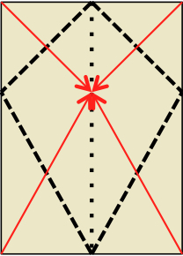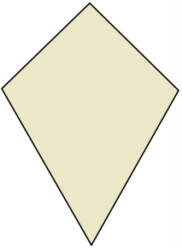
KP | 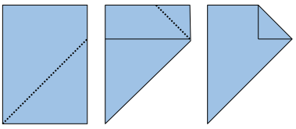 | Why is the result a kite?  What assumptions are you making?
KA | 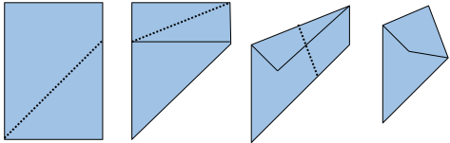 | Why is the result a kite?  What assumptions are you making?
KS | 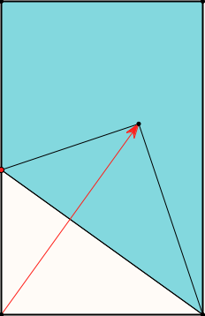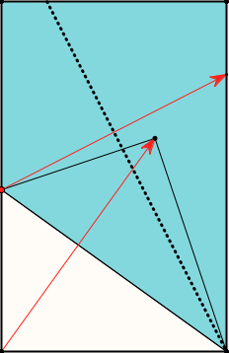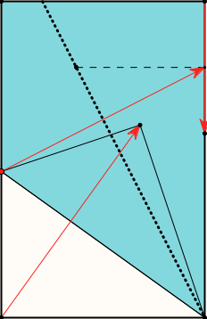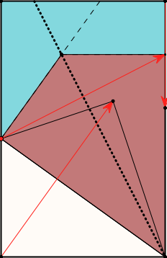 | Why is the result a kite?  What assumptions are you making?
KV | 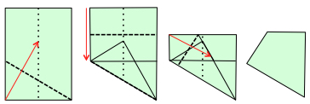 | Why is the result a kite?  What assumptions are you making?  Verity’s Kite  counton.org/explorer/origami/veritys-kite/

Notes
KO: the most likely candidate unless you have origami experience, is as shown. Only assumptions required concern folding as a symmetry.
KP: Pythagoras may be useful.
KA: It is necessary to assume that the paper is in the same ratio as A4 paper, √2 : 1. Focusing on angles may be helpful. Recognising √2 – 1 as the tangent of 22.5° proves useful.
KS: no assumptions on paper shape. Attention on symmetry may be useful.
KV: no assumptions on paper shape. Recognising a 30–60–90 triangle and-or an equilateral triangle may be helpful.

Pedagogic Issues
How might one direct attention to Pythagoras, angles , 30–60–90 triangle or symmetry as appropriate?
The mathematical theme of organising & characterising is in play to distinguish between kite folding that requires rectangular paper in a given ratio, and kite folding that does not.

Extensions
Kites are a subclass of the collection of quadrilaterals for which the alternating sum of the squares of the edge lengths is zero. (Take the edge lengths in cyclic order; square them; alternately add and subtract; the result is 0). This can be emphasised by constructing squares on the edges and colouring them alternately.
It turns out that adjoining two such quadrilaterals along a common edge retains the alternating sum of the squares of edge lengths being zero. Notice the theme of invariance in the midst of change.
Which of the kite constructions provides kites that can be joined together edge to edge to make a polygon with central symmetry?
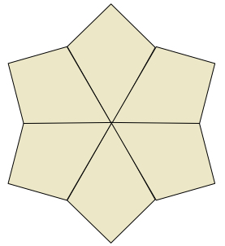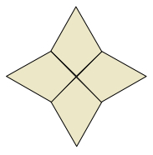
One instance of an alternating sum of squares being zero is achieved by starting with an acute angled triangle, choosing a point in the interior, and dropping perpendiculars from that point to each edge.
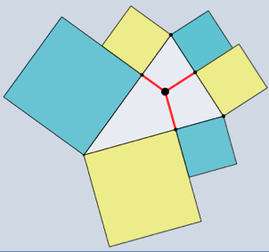
The vertices together with the feet of the perpendiculars can be thought of as a hexagon, and for this hexagon the alternating sum of squares of edge lengths is zero, as can be seen by using Pythagoras six times.
It is also true that any polygon for which the alternating sum of squares of edge lengths is zero can be decomposed into quadrilaterals satisfying the same property. Notice the theme of doing & undoing.

