Dose of Don 6: angle bisection, incircles and reasoning with ratios
This is the sixth of a very irregular series of writings in which I (and, I hope, others) delve deeply into the collection of tasks on Don Steward’s blog https://donsteward.blogspot.com/ and pull out threads about key ideas in mathematics that run through several of his tasks. Where possible I give you a direct link to the tasks; where I have extracted part of a task I direct you to the ‘parent’ from which it came.
Don was very generous with his tasks and I hope that you will return this generosity in the way he requested before he died, namely to donate to https://www.justgiving.com/fundraising/jessesteward

This ‘Dose of Don’ is different in flavour to my previous posts. Instead of following what has been stimulated for me in his work I am following a thread of his own inquiry. For a workshop on angles he presented some tasks that depended on defining an angle by its tangent ratio. I talked about this in my first ‘Dose of Don’ blog (http://www.pmtheta.com/dose-of-don.html) as he had a theory that if you approached angle by limiting it to those that could be expressed on a square grid, then many angle and trigonometric facts, and other geometrical insights, could be deduced in special cases and that possible generalisation to all angles could be explored. The angles that can be expressed on a square grid and those whose trig ratios can be constructed on the lattice points, e.g. in triangles for which some of the side lengths can be expressed as rational multiples of each other. To simplify this he limited exploration at first to those angles whose tangent ratio was ‘on the grid’, so angles are an inverse of ratios, not yet expressed in degrees or radians.
OK so far?
Then he began to explore angle bisectors. I had forgotten this direction but found it again while tidying my desk and finding my scribblings. Most of what I found is at : https://donsteward.blogspot.com/search/label/angle%20bisector
He starts by suggesting you use a compass/straight edge approach to bisecting an angle and observe whether and where your bisector passes through lattice points. There is then the following summary slide about what you might have found (a typo for tan B/tan 2B is easy to spot).

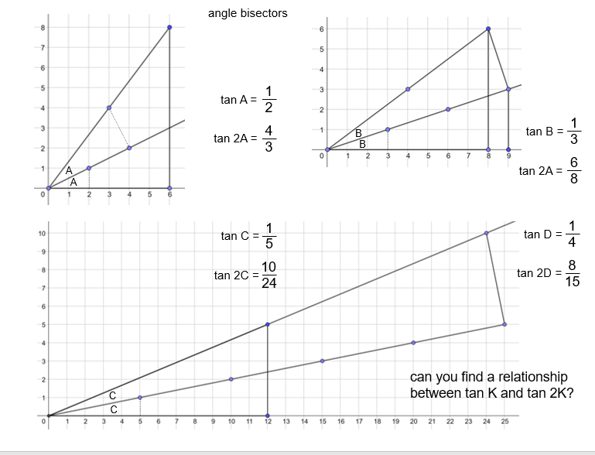
Now the reason I had put this to one side for over a year is because my knowledge of double angle formulae is robust even 60 years after I first met them and this seemed to be getting in the way of imagining how learners might answer the question about a relationship between K and 2K. Could I honestly reconstruct a relationship I knew without using it as a ‘goal’? In other words, could I treat the K question as a goal-free problem? I could pick out features of the diagram and confirm them by using existing knowledge. I don’t recall, however, ever using the tangent double angle formula to find the tangent of a half-angle – the information I need to bisect angles on the grid. After some manipulations I found out how to do this and realised that this is how Don must have developed the particular examples he offered and why (you may have noticed this) they seemed to need Pythagorean triples to ‘work’. But I have not answered for myself the question of how anyone who was not familiar with double-angle formulae might approach the bisection question.
Another way to approach the bisection question is to use knowledge of incircles to do some reverse reasoning: if angle bisection gives me the incentre, then the incentre will give me clues about angle bisectors. Triangles on grids, particularly right-angled triangles with their legs on the grid, offer several reasoning routes and – hey presto! – the tangent ratio for the half-angle plops out before your very eyes!

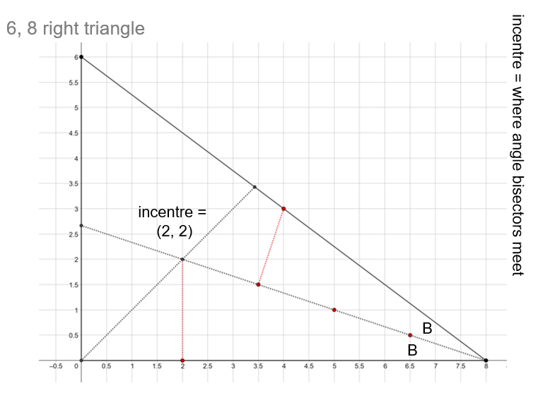
This line of reasoning depends on some lines of thought that might be more familiar than inverse tan and Don’s slide number 30 can take you there. It is a free-standing exploration that depends on knowing about areas of triangles and Pythagoras.
A diagrammatic approach I particularly like follows:
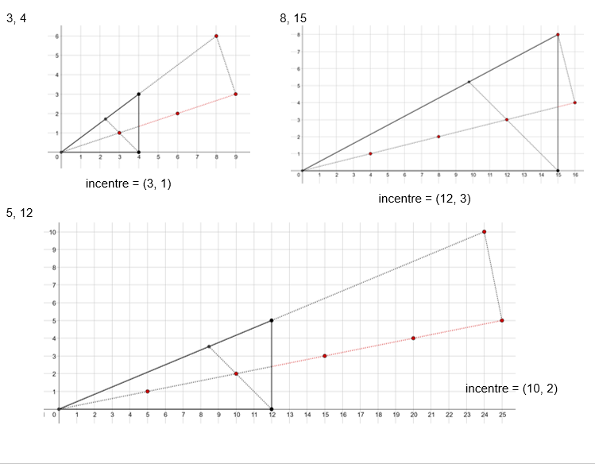

I found it is possible to reason the relationship between the half angle and the full angle without thinking about incentres but instead by reasoning with ratios. To show that the two half angles are equal (and therefore must be halves of the full angle) I only have to show that their tangents are equal, i.e. that their defining ratios are equal. The unit lengths in which the ratios are constructed don’t matter. I love this. For me, it is about seeking similar triangles using lattice points.
During our time with Don, JohnM and I raised an issue that has been hanging around for years: reasoning with ratios can be very powerful but we rarely see diagrams from which ratio ‘jumps out’ obviously as an important underlying relationship. We cannot ‘see’ ratio; we have to reason it out. I suppose the same can be said for multiplicative relations more generally; we cannot ‘see’ them in the same way as we can ‘see’ addition or difference. We think Don worked on this in his grid tasks but never had a conversation with him about it. However, I have found four diagrams that suggest he had found something. I cannot find them on his website but maybe have not been looking in the right place. I have reconstructed them here, because my copy is covered with my scribbled workings-out which could be a distraction (e.g. ‘can’t see ratios’, ‘try 3:2 along hyp’ etc.)

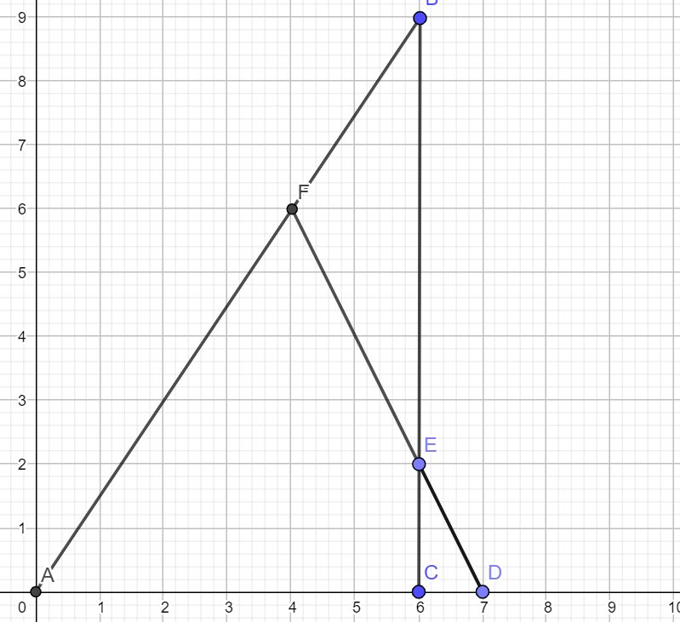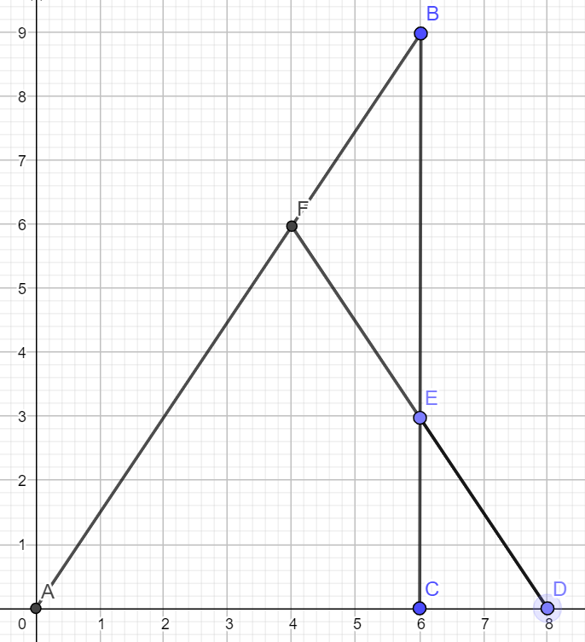

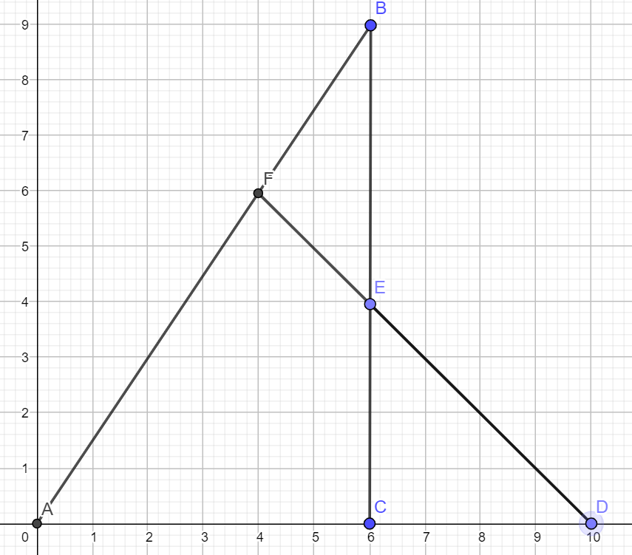

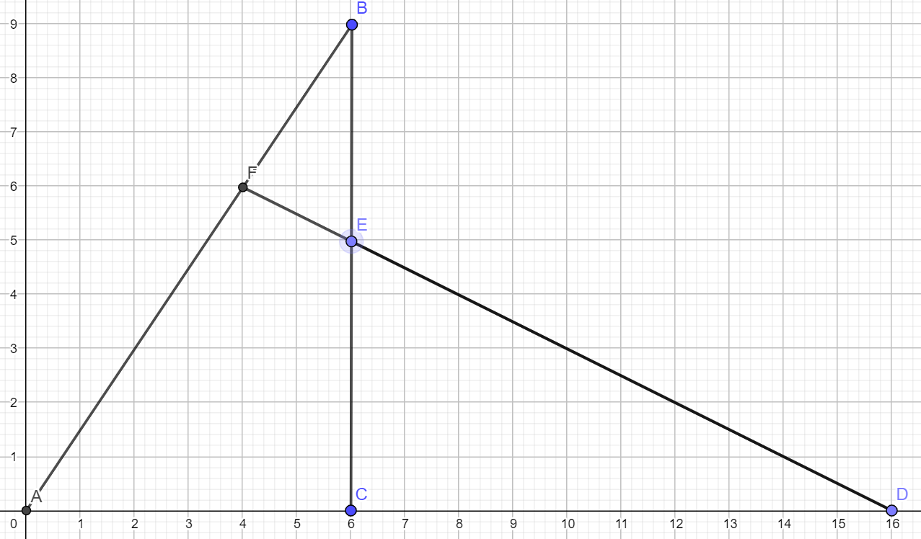

Finally, if you have got this far, a pedagogic question: how do the variation and invariance in these four diagrams help or hinder understanding and generalising the underlying relationships?

