Dose of Don 5: Substitution
This is the fifth of a very irregular series of writings in which I (and, I hope, others) delve deeply into the collection of tasks on Don Steward’s blog https://donsteward.blogspot.com/ and pull out threads about key ideas in mathematics that run through several of his tasks. Where possible I give you a direct link to the tasks; where I have extracted part of a task I direct you to the ‘parent’ from which it came.
Don was very generous with his tasks and I hope that you will return this generosity in the way he requested before he died, namely to donate to https://www.justgiving.com/fundraising/jessesteward

John and I hosted a day’s online workshop on ‘Substitution’ recently. Don attended our day workshops regularly and always had something extra, interesting and challenging to offer so we co-opted him onto our team. Hence the workshops we have hosted since May 2020 have always reminded us of him. So I was wondering how Don used substitution in his tasks – whether he made a Big Deal of it or not. We posed the question at our workshop: ‘Is substitution a Thing?’ Our answer in the day was ‘Yes’ as substitution crops up all over mathematics; the purposeful substitution of one expression for another to simplify, gain insight, clarify, test, modify, make new things possible, etc. etc.
Shortly after this Richard Perring posted a tweet asking the same question but from a different perspective. His question was about exercises in subbing numbers into algebraic expressions in early algebra. You know the kind of thing, the internet is full of them, e.g. ‘If p = 2; q = -6; r = 10, calculate -pq²r^{3’}. The exercise is not about algebra, it is about calculating with negative numbers once you have understood the syntax of the symbol system. It changes algebra into numerical answers. By contrast this task: ‘If p = 2; q = -6; r = 10, find at least five different algebraic expressions whose value is 4 using as many of the letters and mathematical signs as you need’ focuses on turning arithmetical understandings into algebraic expressions and launches ‘what if …?’ questions.
So I began to search Don’s collection of tasks to find places where substitution gives useful mathematical perspectives and handles.
I didn’t have to look very far: https://donsteward.blogspot.com/2020/04/two-types-of-sum.html
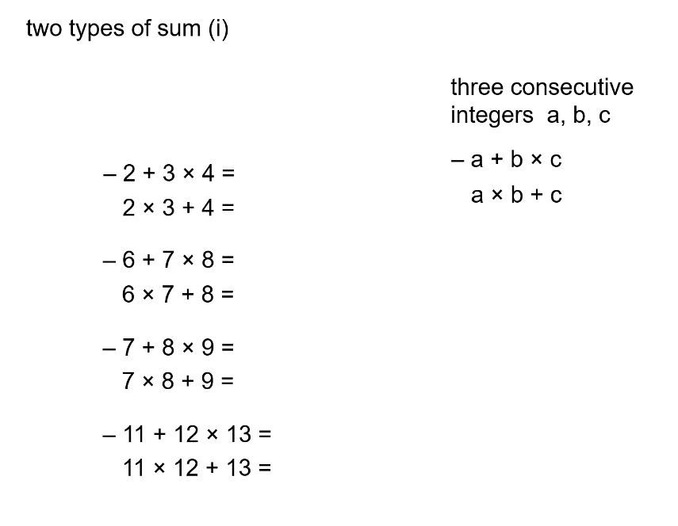
Think of substituting expressions for consecutive numbers into a,b, and c (which are generalisations but not very helpful ones) and you have the beginnings of a ‘proof’ for conjectures that arise from doing the calculations. A dance begins between generalisations, structure, examples and relationships that is typical of mathematical exploration and the associated questioning: ‘What can I write instead of ….?’ ‘Can I test that with an example?’ is often about substitutions that are helpful in revealing or expressing structure.
And a later slide of Don’s gives:

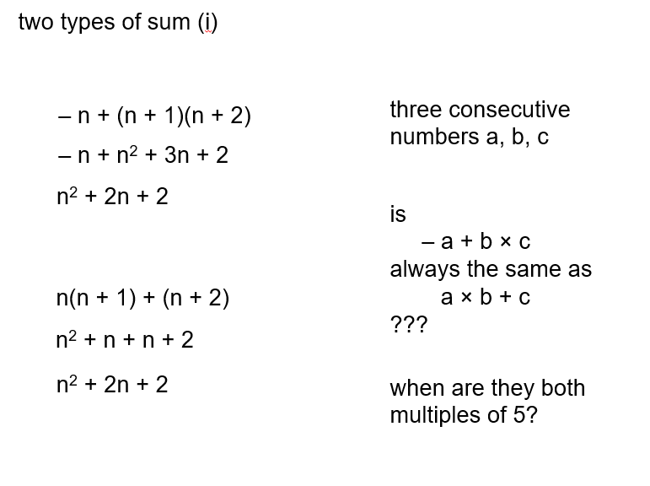

This gives a reason for becoming more fluent with such manipulations - ‘doing’ algebra with a purpose. There’s more but you’ll have to go to his website for that while I indicate some other things I found once I had ‘substitution’ in my sights.
I have to force myself to open files with titles like ‘decimal subtraction’ but here goes: https://donsteward.blogspot.com/search/label/decimal%20subtraction .
This does not disappoint; I have had some great fun showing only the first two lines to people and seeing what happens. I got myself hooked on wondering about the cyclic nature of what appears and rewriting numbers as sums of powers of ten, i.e substituting the separate place values into the ‘answers’. This is the ‘undoing’ of what is done in primary school to build up multi-digit numbers from the place value components and is the basis for many mental methods in Vedic mathematics and Trachtenberg methods (see Google for these) and an old method that was taught in schools in the 18th and 19th century called ‘casting out nines’. Some people immediately substituted ‘nine tenths of…’ for the left hand sides, which explains something about the answers you get but not (for me) the cycles. The immediacy of this response was impressive but they were all people ‘of a certain age’ for whom expressing rational numbers as fractions retains some of the manipulability that can get lost in decimal notation. So there are two kinds of substitution at work here, both about equivalent numerical structures, used to explore and then explain the generic behaviour seen from the specific examples.
This reminds me of a feature of substitution that exposes its purposefulness. Firstly, it is a two-way action in which some things are gained and some are lost: generality/specificity; approximation/accuracy; manipulability/visualisation etc. This last duo comes from thinking about modelling phenomena, but also from substitutions that change bases, such as are done in order to integrate functions.
Don’s website holds many tasks in which substitution is more explicit than what I have offered so far, see https://donsteward.blogspot.com/search/label/substitution. Martin Wilson of Harrogate is credited with some of the ideas. There are several of these that can be explored by trial and adjustment, i.e. purposeful substitution to get a ‘feel’ for what is going on and also raw material for later reflection – why these numbers? Both the sets below use structures which we hope will become familiar for learners but also have extra features to think about. I could imagine learners being asked to ‘make up some of your own like these’ and hence writing algebra for themselves, having used substitution to test their inventions – some two-way number/algebra thinking.
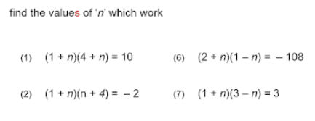
You might be wondering about a place in the curriculum where the word ‘substitution’ is used explicitly – the solution of simultaneous equations. In our workshop, and also in some of Don’s tasks, a powerful use of substition turns out to be the use of equivalent algebraic expressions, or temporarily equal expressions to simplify the use of variables. A really simple version of this reasoning is: if a = b and a = c then b = c, and a, b and c can be substituted for each other. Here is a development of that, where expressions rather than individual letters can be manipulated to ‘reduce’ the number of variables in a situation (https://donsteward.blogspot.com/2016/03/find-expressions.html ). The task is to express a, b and c in terms of n. Rather than using the language of moving terms to and fro over the equals sign like deranged chess pieces the language of logical arithmetical reasoning can be used. For example, in the first set: ‘if b – c = n, then I also know that c = b - n; does that help?’ The standard question: ‘if I know …. then what else do I know?’ kicks in big time when transforming algebraic expressions. New expressions for a and b can be substituted into the first equation.
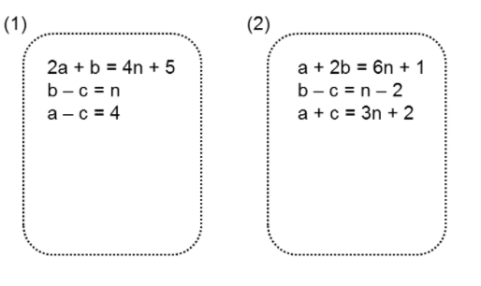
This realisation, that so much mathematics depends on substituting one expression for another when building expressions, equations, mathematical models and so on, seems to get lost in formulaic approaches to simultaneous equations. The idea of substituting expressions into other expressions has recently made more sense to me than the traditional ‘elimination and substitution’ language of methods. For example Don’s ‘where do the lines meet?’ tasks (https://donsteward.blogspot.com/search/label/simultaneous%20equations) cry out ‘substitute for y in the second equation’ rather than the ‘rearrange and match coefficients and subtract the equations’ that appears in some textbooks.
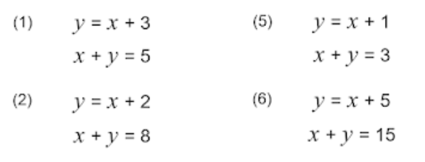
I am not saying that this kind of substitution can be used to solve all such problems, but the awareness of the power of substituting one expression for a variable or another expression pervades mathematics, so a common pedagogic question could be: ‘is there a substitution that can be made from the given information that gives insight/simplifies/gives some traction?’ Being a bit fanciful – this could even be used in angle-chasing situations. I suspect that if John and I wrote ‘Questions and Prompts for Mathematical Thinking’ today we might include a question of this kind that could turn many procedural tasks into something more creative.
In my next Dose of Don I shall return to finding inspiration in his tasks rather than imposing my own perspective on them.

