Dose of Don 2: Straight lines
This is the second of an irregular series of writings in which I (and, I hope, others) delve deeply into the collection of tasks on Don Steward’s blog https://donsteward.blogspot.com/ and pull out threads about key ideas in mathematics that run through several of his tasks. Where possible I give you a direct link to the tasks; where I have extracted part of a task I direct you to the ‘parent’ from which it came.
Don was very generous with his tasks and I hope that you will return this generosity in the way he requested before he died, namely to donate to https://www.justgiving.com/fundraising/jessesteward

In Dose of Don 1 I focused on a particular feature of Don’s work on grids. I think of this as ‘that little triangle’ – a right angled triangle that, nestled up to a straight line on a grid, can be used to define angle, gradient, tangent, direction, distance between two points, rate of change, ratio, instantaneous change and so on. I am sure I will come back to this triangle again. For now, the multiple roles played by ‘that little triangle’ made me zoom in on expressions of the form ‘mx + c’ or ‘kn + c’ where the common use of x is for continuous variables and n for discrete variables. One thing I realised is that an expression like kn+c can be seen as a member of a family of multiples of k with remainders. For example, any whole number can be written as 4n, 4n+1, 4n+2 or 4n+3. Any whole number is either 0(mod 4), 1(mod 4), 2(mod 4) or 3(mod 4). The parallel lines y = 4n + c are all the same line translated vertically according to remainder c when dividing by 4. The ‘undoing’ of 4n+c can be understood as ‘subtract the remainder to get back to the multiple, then divide by 4 to get back to n’, which is the same as saying that the equations: y = mx + c and x = (y-c)/m are equivalent, which of course you know but the context or resurrecting a division from its whole number and remainder parts seems to be a good context for thinking about transforming equations (finding equivalent ways to express the same relationships) rather merely going through some manipulations to solve something.
Don poses a raft of questions about properties of any four consecutive numbers, many (but not all) of which can be proved by using expressions 4n+c. For example, if their sum is 130, what would the numbers be? (https://donsteward.blogspot.com/search/label/consecutive%20numbers). The algebra associated with this question is of the same kind as finding expressions for perimeters. On the same page he offers an enigmatic slide that combines mod 3 and mod 4 when the ‘n’ in a linear expression is itself a linear expression. I have a bit of a ‘thing’ about substitution when it is given as a pointless exercise which focuses on calculation rather than structure, so I enjoyed this slide because it needs the distributive law and would look good represented by cuisenaire rods or even two connected cogs (If 3n+2 turns of one cog make a bigger cog turn once, then ….?).
So far, the use and meaning of algebra comes through the questions posed. How does he approach the more procedural necessities of working with linear expressions? The following two slides show a commitment to structure and meaning. My personal approach to algebraic expressions is to avoid doing anything to them unless I know it is necessary and can anticipate its use. So with these slides I did not start by ‘what should I do?’ but ‘what are these telling me?’.
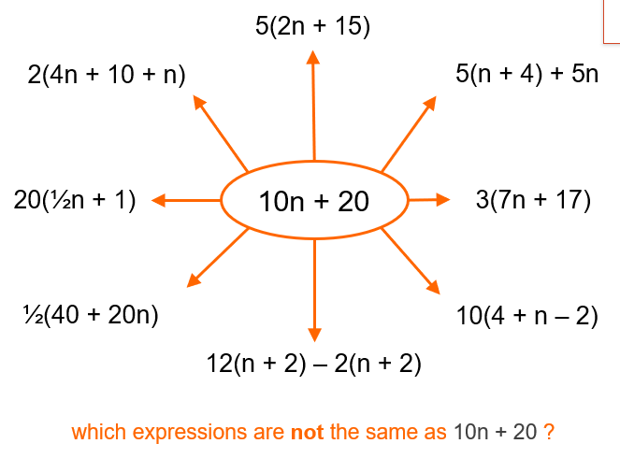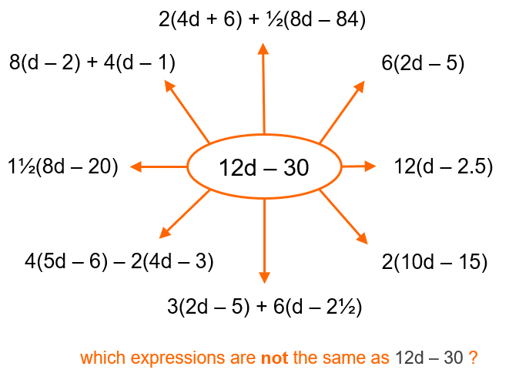
These are from https://donsteward.blogspot.com/2018/01/algebra-snakes-and-branches.html in which much of the emphasis is on building and transforming expressions so that given expressions can be read with meaning.
I have offered these to various teachers and also young learners and there seem to be two reactions: one is to multiply out all the brackets, simplify and compare whole expressions; the other is to think about their constants and eliminate those that cannot have the right constant, then check the number of ‘n’s’ and eliminate any cannot have the right number, then check by substitution e.g. 1 for n or d (do you need two values?). This approach uses the meaning of the distributive law and substitution can be used to find out what the effect on ‘-3’ is of subtracting 2 times it on one of the examples on the right hand side. However, asking ‘what are these telling me?’ reveals some care in devising these examples. I am not going to point out everything I observe but, for example, look at how (n + 2) appears in various guises in the left-hand example. Something similar lurks in the right-hand example. ‘Multiplying out’ loses those observations that would significantly reduce the work by recognising structures.
This ‘what is it telling me?’ approach to algebra has echoes throughout his collection of tasks. Here are a couple of slides that embed the question: ‘if I know this – what else do I know?’
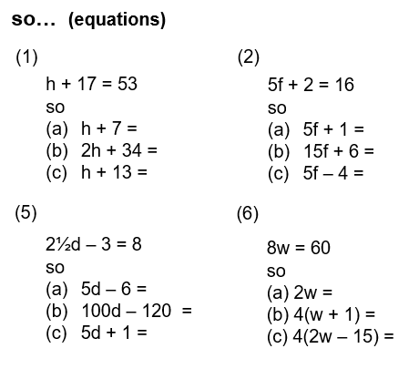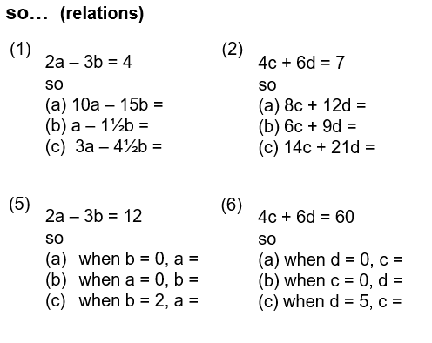

These are from a slides entitled ‘so, linear’ https://donsteward.blogspot.com/2015/06/so.html. He says on the website that ‘legitimately going from one statement to another (is kind of what maths is about)’ [his brackets]. This is so deep but so understated.
The shift from thinking of linear form as the generalisation of ‘mx + c’ to ‘ax + by’ is one I need to explore more. I recognise that a graph that can be written as ax + by = c is a variation on x + y = 1, with the associated ease of finding intercepts on both axes. It looks as if Don had that in mind with his suggestions of substituting zeroes in the righthand slide. It also looks as if he had the requirement for algebraic solutions to simultaneous equations in mind with some of these transformations.
Here is another example of the need to recognise the algebraic format of linear graphs with a typically playful task. https://donsteward.blogspot.com/search/label/graphs. Why has he chosen to use similar numbers in most of these? How might learners’ approach to this task vary if the axes were not similarly scaled? How many of these can be ‘seen’ as variations on x+y=1?

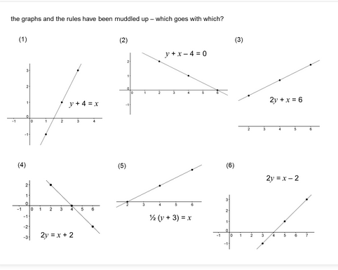

Finally I find myself returning to a task I posted in Dose of Don 1 called ‘integer intersection points’ that can be found at https://donsteward.blogspot.com/search/label/straight%20line%20graphs. I return to thinking again about straight line graphs as representations of similar triangles, every pair of points on the line being the vertices of a right-angled triangle whose vertical and horizontal lengths are in a fixed ratio. Because my approach to these does not seem to match his, I am left with the intrigue of working out his train of thought and talking to myself about its equivalence to mine.

