Dose of Don 1: Lines and angles on square grids
This is the first of an irregular series of writings in which I (and, I hope, others) delve deeply into the collection of tasks on Don Steward’s blog https://donsteward.blogspot.com/ and pull out threads about key ideas in mathematics that run through several of his tasks. Where possible I give you a direct link to the tasks; where I have extracted part of a task I direct you to the ‘parent’ from which it came.
Don was very generous with his tasks and I hope that you will return this generosity in the way he requested before he died, namely to donate to https://www.justgiving.com/fundraising/jessesteward
In this cluster of tasks I have identified a key idea in secondary mathematics, gradient, and pulled together some of Don’s tasks that use squared or dotty paper to explore straight line geometry and associated relationships. You will see some obvious links to ratio, enlargement, congruence, linearity and the use of gradient arising in several proofs about angles.
A core idea is that the horizontal and vertical distance between dots or intersections can be taken to be 1 unit apart. Another core idea is that, on a square grid, the relationship between distances along and up (or down) define direction, angle and gradient for a straight line. In ‘grid geometry angles’, angles are defined by the grid but you might choose not to progress to talking about inverse tan at an early stage (https://donsteward.blogspot.com/2017/07/grid-geometry-angles.html). This suggests a core tool for angles, lines and gradient will be right-angled triangles where the hypotenuse lies along the line under consideration. At first no knowledge of Pythagoras or trig is necessary or implied.
Gradient is a key idea in thinking about parallel and perpendicular relationships between straight lines. You could start with a task sequence where the the final task is to find points on a grid that complete parallelograms (https://donsteward.blogspot.com/search/label/parallel%20lines) which includes these beautifully chosen examples of ‘parallel or not?’:
This approach extends to perpendicularity; the early part of this sequence can form the basis for discussion about the relationship between the right-angled triangles formed from perpendicular lines (https://donsteward.blogspot.com/search/label/perpendicular%20lines) which opens with ‘perpendicular or not?’ tasks.
If the gradient of one line is m, the gradient of a perpendicular line is -1/m and this can be deduced from using right-angled triangles on the grid to indicate gradient. The latter part of this task sequence approaches similar content as before using inverse tan and angles. Inverse tan can be avoided because the final part does not need the inverse tan approach and examines the relationship between diagonals of kites, but you would be losing Don’s assumption that introduction of inverse tan is an interesting and purposeful start to trigonometry.
Lengths and midpoints of line segments on squared grids can be discussed without needing Pythagoras or coordinates as prerequisites. Rules can be deduced from describing what happens on the grid, e.g. ‘length’ of a hypotenuse is fixed by the other two sides of a right-angled triangle, even if we cannot yet work out its value. Mid-point of a segment can be fixed by halving the along and up distances. Tasks that follow on from these ideas can be found on https://donsteward.blogspot.com/search/label/angles%20on%20parallel%20lines and also in this line segment ratio task (source page unknown):
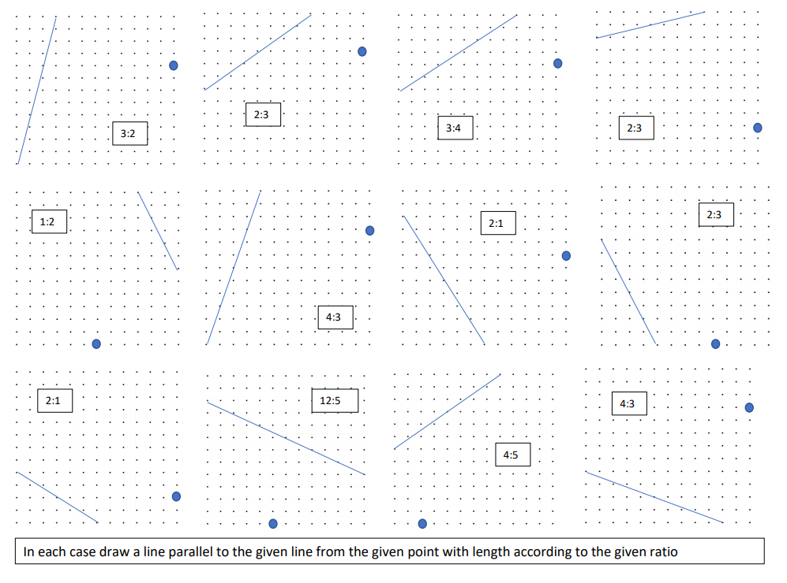
This approach could be used to develop a need for Pythagoras’ theorem and/or labelling the hypotenuse length as ‘h’ and working algebraically.
Don used ‘rise over run’ to describe gradient (the inverse tan of an angle) but I would choose to start by posing two questions: ‘How far do I rise or fall if I go along 1 unit?’ and ‘How far along do I have to go to get a rise or fall of one unit?’. Posed this way with the emphasis on ‘along’, the x-ordinate on a coordinate grid can be treated as the independent variable and the ‘rise’ as the dependent variable, the y-ordinate, and the position number in a linear sequence can be the horizontal, or the function input, and the vertical distance is the function value, or output. This means I can shift from squared paper to a coordinate grid and ask similar questions to those above, using the visual similarity, but this time require coordinates as answers. Done this way (geometry first, coordinate grid after) the mathematical purpose of coordinate axes, i.e. tools to represent relationships, makes sense. An approach to sequences presents linear sequences on a coordinate grid. The linear rules derivable from translated letters develop by sight and the gradients on squared paper can be represented with coordinates.
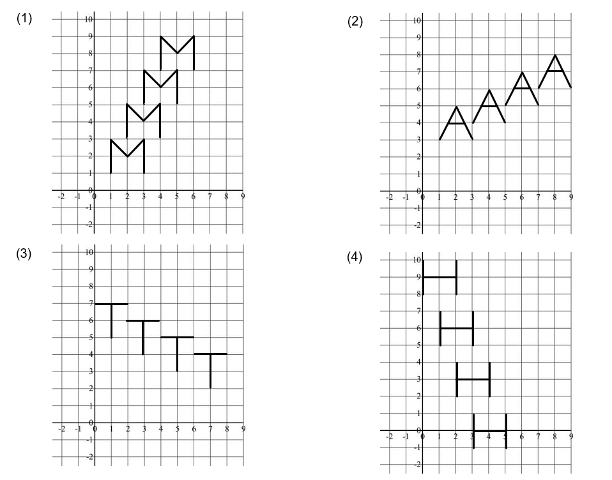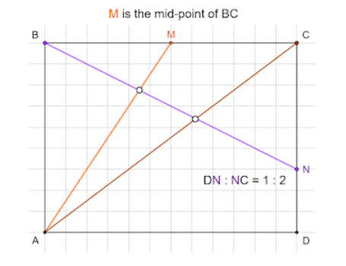
These tasks lurk in https://donsteward.blogspot.com/search/label/straight%20line%20graphs along with along with ‘integer interaction points’ using integer solutions only, so grid geometry is still a possibility.
So far, the overt use of inverse tan has not been necessary, but Don takes the introduction of trig in interesting directions, claiming that important ideas in coordinate geometry and trigonometry can develop from the limited world of square paper and seeing angles as the ratio of sides of right-angled triangles. For example: angle bisection using grids can be found at: https://donsteward.blogspot.com/search/label/angle%20bisector; and there is some interesting and more challenging work with inverse tan at: https://donsteward.blogspot.com/2020/03/using-arc-tan-within-triangles.html and https://donsteward.blogspot.com/2020/03/two-angles-sum-to-45-degrees.html.
I can almost promise you – if you have stayed with me so far – that you may never look at inverse tan in the same way again.

