Notes on Transitions from Arithmetic to Mathematics

John Mason  
Fields Institute  
Mathematics Education Research Forum  
Jan 28 2023

These are notes to augment the PPT slides (Mason webref) of a presentation to the Fields’ Institute Mathematics Education Research Forum in January 2023. The session title was

School Arithmetic is to Mathematics,   
as Making Sounds is to Music:  
some pedagogically supported transitions   
from arithmetic to mathematics

My starting point is that arithmetic (calculations with numbers) is NOT in itself mathematics. Mathematics is the study of relationships, so arithmetic becomes mathematical when the objects of study are relationships between numbers and beyond.

Making sounds is making sounds; when sounds follow in some sort of sequence, they can become or experienced as a tune, and when they are made together they can be experienced as harmony. Both tunes and harmony are relationships between sounds.

So too school arithmetic is concerned with performing calculations, accurately and swiftly. But that is analogous to making sounds. What really matters, what created mathematics, is recognition and study of relationships between numbers.

So for example when you see the task

48 + 69 – 49 – 68 = ?

People often start calculating: 48 + 69 then – 49 etc. They enact the first action that becomes available to them. An alternative is to become aware at some point, perhaps as they sub-vocally read the numbers, that there is a +40 and a –40, a +60 and a –60 etc. so that the answer is 0, without calculation. Pedagogically this is the use of pausing to consider alternatives to the first available action, in case there is something more efficient just below the surface.

The next task was

748 + 369 – 769 – 348 = ?

Alerted to looking out for relationships, you might immediately see that the answer is again 0. The reason is that each digit appears in the same tens-place in both a + and a – number. But to do this requires either a sensing of a relationship while sub-vocally reading, or intentional movement of attention between details of the numbers, seeking out relationships.

The third task was

748 + 369 + 251 – 761 – 358 – 249 = ?

Something similar is available. I then asked people to construct their own task ‘like this’; then another; then another. Well aware that this sort of task is not a challenge to the people present, I proposed that their aim could be to try to catch how their attention shifts, and how the way in which they attend, shifts. For it seems to me that learning mathematics is about learning what to attend to, and in what ways.

## Interlude

I actually began with some remarks about my fundamentally phenomenological stance, so that what is available from the session is what people notice about how their attention shifts, in relation to the conjecture that when teacher and learners are attending to different things, and even when attending to the same things but differently, communication is likely to be impoverished. Put another way, breakdowns in classrooms may be mostly due to different people attending to different things or at least attending to them differently. Consequently as a teacher it is vital not only to be aware of what I am attending to, and how I am attending to it, but what pedagogic actions could be invoked in order to bring attention into line.

I have found the following distinctions useful in attending to how I am attending to things mathematically:

Holding Wholes (gazing)

Discerning Details (which can become wholes for further gazing)

Recognising Relationships (amongst discerned details; amongst relationships; …)

Perceiving Properties as being instantiated

Reasoning on the basis of agreed properties

The shift from recognising a relationship to perceiving it as an instance of (a more general) property may be the single most important experience to make mathematics engaging and learnable. Captured in the slogan ‘seeing the general through the particular’, and its converse, ‘seeing the particular in the general’ (Mason & Pimm 1984), these shifts can reveal mathematics as a constructive, creative human endeavour, rather than a collection of procedures to internalise, and in particular, can turn the tedium of arithmetic into the wonder of mathematics.

The overall structure of the session is to remind people of three pedagogic actions which can help ease the transition from arithmetic to algebra, bearing in mind the observation of my friend and colleague Dave Hewitt, that in order to do arithmetic, you have to think algebraically.

# Tracking Arithmetic

In the PPT I used two different contexts to illustrate the principle of tracking arithmetic, which was inspired by the writing of Mary Boole (Tahta 1972). The idea is to choose one or more parameters in a task and to isolate them from calculations, so that their presence is constantly visible. Then each parameter is exchanged for a symbol: at first, a single parameter is replaced with a little cloud, representing ‘the number that someone (I usually refer to my wife at this point) is thinking about’. The notion, the experience, of generality is immediate. Doing this a few times is rarely problematic in classrooms, and the cloud has helped me show algebra-refusers that there is nothing frightening or abstract about algebra.

A third context in the PPT analyses an ancient Egyptian task, showing how I think it was meant to be used with learners, using tracking arithmetic to achieve the intended generalisation.

# Expressing Generality

For me, algebra is about expressing and manipulating generality, despite most textbooks since the 15th century describing algebra as ‘arithmetic with letters’. Questions such as

Why would you manipulate letters? When will that be of value to me?

lie at the heart of algebra-refusing. Algebra has, during my career, been the principal watershed in mathematics, for learners, with fractions a close second. But experiencing the expressing of generality, not just a few times, but on every possible occasion, helps to internalise expressing generality as one of the things that mathematicians do, because of the power it unleashes. Individual exercises turn into classes of problems with a common approach (the generality of which each is an instance)

# Multiple Expressions of the Same Generality

Algebraic manipulation arises for me because when different people express the same generality, they often express it quite differently. There ought to be a way to go between expressions, without having to resort to the original situation. In other words, the rules for manipulating algebra turn out to be the same as the rules for manipulating arithmetic … and so provide a taste of perceiving properties which are instantiated in calculation, whether arithmetic or algebraic.

In the PPT I use a slightly unfamiliar context, namely hexagons, and because I was inviting people to catch shifts in their attention, I chose to display several ways of expressing the same generality rather than inviting people to spend time expressing that generality for themselves. Both call upon shifting attention of course, but I wanted to remind participants that there are different pedagogical actions that can be initiated.

The task is to express how many hexagons would be required to surround a display of *r* rows and *c* columns of hexagons, as illustrated in these two examples.

 

Figure 1: Hexagonal arrays with 2 rows and 5 columns,   
and with 3 rows and 4 columns

I anticipated that time would need to be spent negotiating and coming to terms with the notion of an ‘array’ of hexagons with *r* rows and *c* columns. Recognising the ’presence’ of arrangements of shaded hexagons conforming to 2 rows and 5 columns in the first diagram, and 3 rows and 4 columns in the second is likely to lead to considering what is the same and what different about the two diagrams, about the specified number of rows and columns in each and hence about the relationships. Notice that in the first diagram the columns rise and fall alternately, while in the second, they fall and rise alternately. Once a sense of array is established, these two diagrams can be seen as instances of the property of ‘being an array’ of hexagons. Drawing attention to the action of considering what is the same and what different, or what is allowed to change and what not, are key pedagogic actions which, once internalised by learners, become mathematical actions for them to enact for themselves in the future.

Interestingly some people wondered whether the fact that 2 + 5 = 3 + 4 had any relevance (I had not noticed it in preparation), illustrating how different people attend to different things, and how, if the teacher is present, there are ongoing issues of when and how to intervene in order that attention is directed in fruitful directions.

I then initiated the pedagogical action of inviting participants to make sense of various expressions of generality. An alternative would have been to invite participants to express their own generalities and to illustrate these with shadings, but I knew this would take longer, and my concern here was in providing opportunities to catch shifts of attention within limited time. Furthermore I wanted to emphasise the need to check expressions on other examples, and to develop a narrative which justifies the conjectured expression.

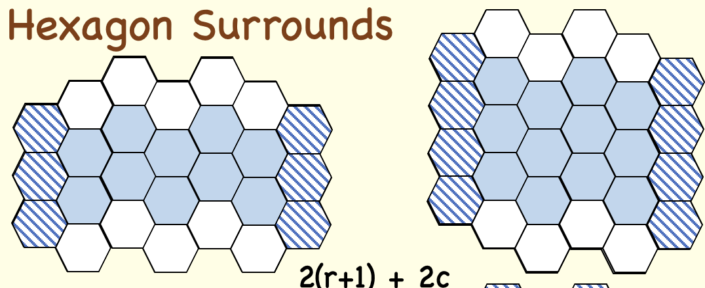 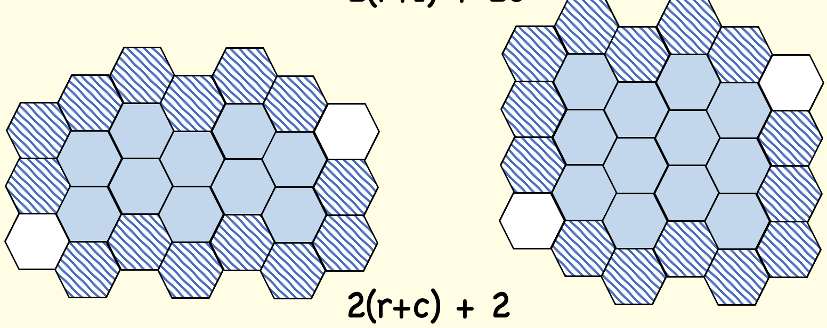

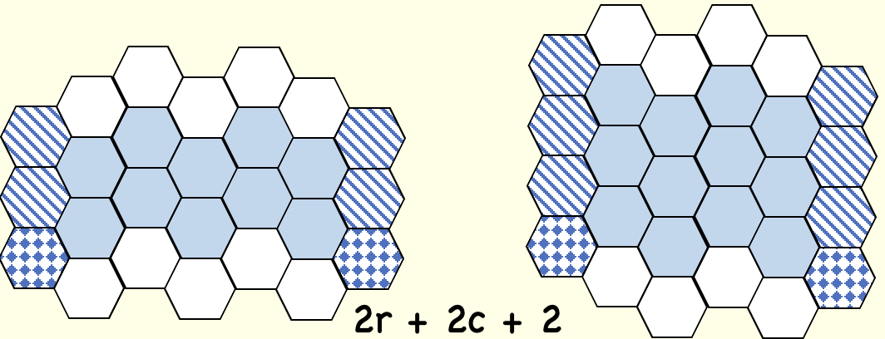 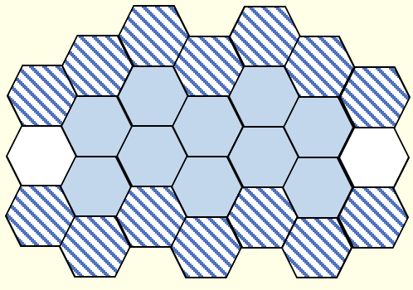 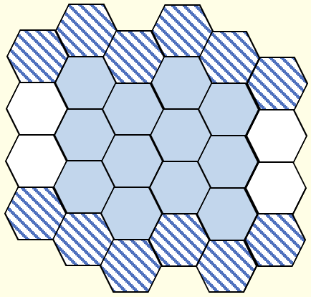

Figure 2: four pairs of ‘seeings’ to be interpreted as expressions of generality.

For example, in figure 2, the crosshatched hexagons on each side of the first pair of arrays are one more than the number of rows, because of the way hexagons pack. The white hexagons correspond to the columns of the array. This action constitutes ‘reading an expression in the context of the situation’, and so justifies the expression in general by seeing the general through the particular. This is the essence of tracking arithmetic in shifting from recognising relationships between discerned details, and perceiving a property as being instantiated in the particular examples.

The fourth pair illustrates how looking at only a single instance, the 2 by 5 array could be misleading when expressing generality, because it might be tempting to conjecture 2(*c* + 2) + 2. Applying this to the second diagram however reveals that the final 2 ought instead to be to be 2(*r* – 1). It is never sufficient simply to ‘express a generality’ because it is necessary to justify that conjecture with some sort of a narrative linking the situation with the expression. Hence the importance of personal narratives for establishing and for beginning the internalisation of a way of thinking, and the value in checking against a further example.

The PPT slides have two further opportunities for expressing generality and for equating different expressions as motivation for algebraic manipulation, all involving hexagons.

# Mathematical Version of Tunes and Harmony

Sundaram’s grid is one of my favourite contexts for inviting recognition of relationships, expression of generality, and the use of manipulation to verify a conjecture. The situation has low threshold (I have used it with primary teachers) and high ceiling (different directions for exploration and generalisation).

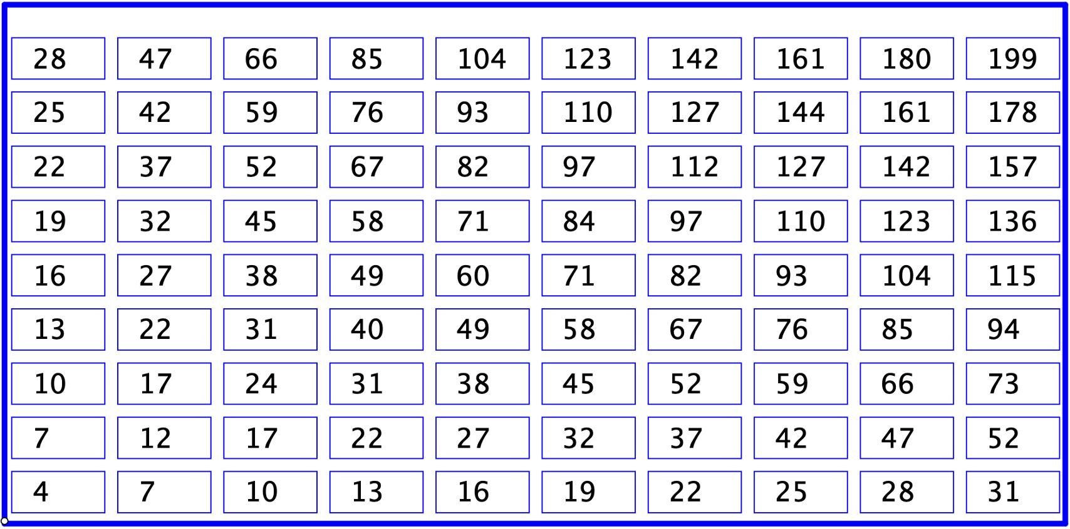

Figure 3: Sundaram’s original grid

Figure 3 shows a grid of numbers in which each row and each column form arithmetic progressions. This means that the invitation is to see the grid as extending effectively infinite both to the right and up. Sundaram’s claim (Honsberger, 1970; Ramaswami Aiyar, 1934) is that if you take the entry in any cell, double it and add 1, the result will be composite (not prime).

In order to justify his conjecture, it is necessary to find an expression for the entry in the *r*th row and the *c*th column, and then to show that doubling and adding 1 leads to an expression which factors non-trivially. Indeed, treating the grid as effectively infinite in all directions, Sundaram’s conjecture can be shown to hold everywhere (extending to the left and down as well) except in one or two rows and columns.

Posing your own problem is usually much more interesting than responding to someone else’s challenge. SPOILER ALERT! I asked myself how many entries can I specify in a grid so that it can be completed to a Sundaram-like grid in which each row and each column is an arithmetic progression. (Notice the shift from recognising relationships to perceiving a property, and then considering other instances.) How would the Sundaram conjecture have to be modified for other Sundaram-like grids? Also, select any four cells on the vertices of a parallelogram, and consider the difference between the sums of diagonally opposite cells of the parallelogram. How is this related to the size of the parallelogram?

# Series and Parallel Arithmetics

The analogy between sound : music and arithmetic : mathematics brought to mind the notions of series (as in tunes) and parallel (as in harmony). It turns out (Ellerman webref) that there are actually two completely parallel arithmetics of fractions, well worth exploring, and deserving of much more care than there is space here. They arise from problems based on a multiplicative relationship such as

distance = speed x time

(number of objects) = (objects per person) x (number of persons)

Voltage = current x resistance

Volume = flow x time

Suppose then that *p* = *r* x *a*, read as “it takes *a* amounts at rate *r* to produce *p*” or as “*p* is producedfrom *a* due to a resistance of *r”*

Consider the following situations:

If *r*1 and *r*2 are happening together for the same amount *a*, then *p* = (*r*1 + *r*2)*a* is the combined effect achieved, so the combined rate *r* = *r*1 +*r*2 which is known as *series* (ordinary) addition.

If *r*1 and *r*2 are working jointly to achieve a fixed *p*, then p over r subscript 1 and p over r subscript 2 are the corresponding amounts to produce *p* individually. Working together, 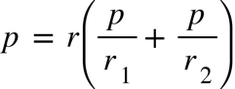 which makes the joint (parallel) rate 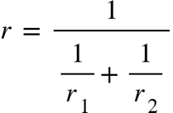 or 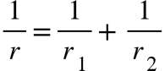.

If *a*1 and *a*2 are each required to achieve *p* separately, then they operate at rates of p over a subscript 1 and p over a subscript 2 respectively. Working together to achieve *p*, 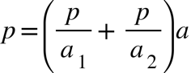 so   
together they need an amount 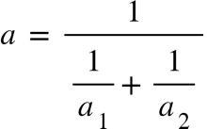 to achieve *p* together. These are known as *parallel* addition, by analogy to electrical rersistance*.*

Pedagogically, considerable time would of course be required working with specific multiplicative relationships and the associated discourse.

Denoting ‘parallel addition’ by r subscript 1 space colon space r subscript 2 then

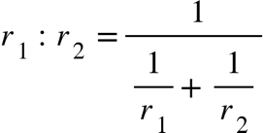 expresses parallel addition in terms of series addition

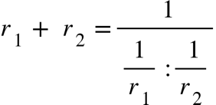 expresses series addition in terms of parallel addition.

What is perhaps somewhat surprising is that parallel addition of fractions (rates; ratios) satisfies all the properties of series (ordinary) addition, such as commutativity, associativity, and distributivity of multiplication over the addition. So there are opportunities to get a glimpse of mathematical structures as sets of objects satisfying certain properties.

# Closing Remarks on Research in Mathematics Education

My last two slides (there was only time for one) raised some concerns and observations about research in mathematics education.

First, what is research in mathematics education for? Whom does it serve?

Obvious responses include

Academic careers?

Publications are the primary basis for appointment and promotion

Path of personal development?

As a practitioner, trying to make more coherent sense of my practice and its implications

Improving the experience of learners?

Surely this is the originating force to engage in research, though the others may come to dominate

Classifying Learners?

Each theoretical frame consists of a collections of distinctions (eg levels, or stages, or competencies or achievements or what is noticed, or …), leading to assessment and evaluation of both learners and teachers

Making predictions?

Theories are generally expected to make predictions: if such and such conditions are present, then such and such is likely (will?) be the outcome.

Informing choices?

Through recognising specific details, suitable pedagogical and mathematical actions may become available to enact

I see theories as sets of labels for distinctions which can be made. The question is whether making that distinction actually makes a difference (Bateson) in how the teacher acts, and hence how the learners’ experience is enriched.

I have long maintained that an architectural image of mathematics education is not appropriate: research does not contribute to building a structure of ‘knowledge’. This is evident from looking at the topics of research papers over the last 50 years. The same topics come up, often but not always cast in fresh discourse. Certainly each generation has to recast insights of the past in its own vernacular. But mathematics education for me is a context for personal development, with the underlying assumption that developments in learners’ experience will follow as a consequence. It is not a matter of replacing old insights with fresh and more precise ones, but rather the development of a positive relationship between the teacher, the content (mathematics and mathematical thinking), and the learner.

The PPT ends with a long list of my own publications that kept coming to mind as I prepared the session. These are but a drop in the ocean of useful and insightful observations of many different authors. But what matters to me is not the ‘body of knowledge’, but the development of the mathematical being of each teacher, each learner, and each researcher.

# References

Ellerman. (accessed Jan 2023). www.ellerman.org/series-parallel-duality-part-i-combating-series-chauvinism/

Ellerman. (accessed Jan 2023). www.ellerman.org/sp-duality/

Honsberger, R. (1970). *Ingenuity in Mathematics*. New Mathematical Library #23. [Mathematical Association of America](http://en.wikipedia.org/wiki/Mathematical_Association_of_America). p 75.

Mason, J. (accessed Jan 2023). [www.pmtheta.com/jhm-presentations.html](http://www.pmtheta.com/jhm-presentations.html)

Mason, J., & Pimm, D. (1984). Generic examples: seeing the general in the particular. *Educational Studies in Mathematics.* 15. 227-289.

Ramaswami Aiyar, V. (1934). "Sundaram's Sieve for Prime Numbers". *The Mathematics Student* **2** (2) p73.

Tahta, D. (1972). *A Boolean Anthology: selected writings of Mary Boole on mathematics education*. Derby: Association of Teachers of Mathematics.

Oxford Feb 2023