Individual Differences in Generalisation Strategies
Rebecca Crisp¹, Matthew Inglis¹, John Mason² and Anne Watson²
¹Mathematics Education Centre, Loughborough University
²Department of Education, University of Oxford

We report a study which investigated how mathematics graduates and engineering undergraduates studied sequential tables of values with the aim of deriving a function. By recording the eye-movements of participants as they tackled this task, we found that there were substantial individual differences in the strategies adopted by participants. However, these strategy choices appeared to be unrelated to both the mathematical background of participants, and their success rates.

Introduction
A common activity in school mathematics is to derive a function from a sequential table of values like that shown in Figure 1.
Given a table of values with two columns, n and f(n) (where n runs sequentially from 1), there are two general strategies one might adopt to determine the function f. First, one might try to determine a connection between a particular n and f(n), and then evaluate whether it holds for other values of n. An alternative strategy would be to look for a relationship between values of f(n) and f(n+1). The first of these strategies entails predominantly horizontal shifts of attention, whereas the second involves mostly vertical shifts of attention. Strategies might be combined. It is assumed, in such tasks, by setters and solvers alike that the data points reveal a well-behaved function that follows a rule rather than (a) discrete points or (b) polynomials of a higher order than can be determined from the given data.

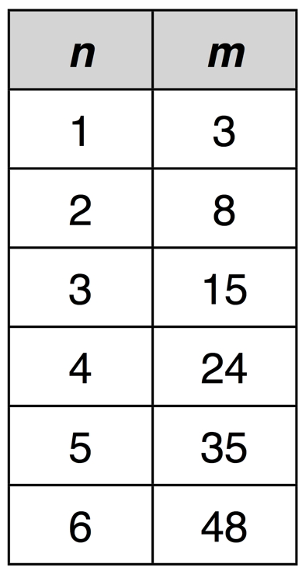
Figure 1. An example of a generalisation task used in our study.

Numerous studies have shown that school students find it hard to shift from deriving a term-to-term recursive formula to identifying the relation between data pairs (e.g. Martinez and Brizuela, 2006; Warren, Cooper & Lamb 2006). Some eye-tracking studies have investigated how students coordinate multiple representations to understand functions (San Diego, Aczel, Hodgson and Scanlon 2006; Andra, Arzarello, Ferarra et al. 2009). The focus in these studies is on coordinating representations rather than the necessary shift from term-to-term relationships to pairwise relationships. We decided to use eye-tracking data to see how novice and experienced mathematicians coordinate what can be learnt from the vertical aspects of such tables and the horizontal aspects, using on-screen presentations of tables of values only. Our aim was to derive insights into how information is sought and processed in typical tabular layouts.
Here we report a study which sought to answer two questions. First, are there individual differences in strategy choices when tackling such problems? And second, if so, are these differences associated with a participants’ mathematical background, or their success at tackling these problems?

Relevant eye tracking studies
Eye-tracking has been an area of research since the 1960s, and more recently is important as a component of studying human-computer interaction. For our purposes the basic belief required is that the study of eye movements can provide an insight into problem solving, reasoning, mental imagery, and search strategies. Most of the published research addresses how people attend to images and text whose only purpose is to research trajectories and duration of gaze for interface design purposes. For example researchers might want to answer questions such as whether visual data is stored in visual or encoded forms, by timing fixations on objects to be recalled or recognised. In our study all data were numbers, so encoding time would only be affected by the participant retrieving characteristics of that number or constructing relations between that number and those seen previously.
Another area of study is about the delaying effects of visual ‘noise’. Findings from these studies might be informative about our subjects’ initial engagement with the screen, but do not give information about any deliberate cognitively-guided trajectories and fixations which might arise from meaning-making processes in a fairly familiar environment. It also provides support for some basic assumptions, i.e. that the longer the fixation on an on screen object, the more attention is being paid to it and the more processing being done with it; and more fixations might indicate a less efficient visual search (Poole and Ball, 2006; Just & Carpenter 1976).
Our research is not about objects but about relations between objects. These relations are being mentally constructed as conjectures and then, presumably, tested, adapted and verified using further data. We would expect, based on our experience as mathematicians and teachers, that the accumulation of data would have an influence and, what is more, in our study we expect eye-movement to have significant deliberate control, probably overlaid with other forms of visual searching. The items we offer subjects are not to be compared to a remembered bank of items, but to be acted upon and encoded in certain ways and the further stimuli sought to compare to those relations by generalisation. Shifts between positions are taken to indicate searching, while fixations are taken to indicate processing (Goldberg and Kotval 1999) with larger shifts being more likely to indicate searching than being attracted by visual proximity (Goldberg et al. 2002).
Poole and Ball’s (2006) summary of the eye-tracking research indicates that most studies do not consider semantic correlation, i.e. the construction of meaning, associated with gaze. For example, regressive saccades (movements between fixation positions) are taken to indicate a processing difficulty, whereas in our study a regressive saccade could be for mathematical verification or to start a new line of enquiry. Therefore we decided what to measure by thinking about what is necessary mathematically in order to collect essential information to identify a function, i.e. vertical comparisons of function values and horizontal comparisons of data pairs, with possibly particular searches for special cases which might yield useful information. Success in such tasks might depend on looking for difference patterns, identification of constants, recognition of number characteristics, recognition of growth rates, and so on. Gould (1973) observed that the vertical field of view appeared to be more limited than the horizontal field, so we can assume that use of vertical data-seeking in our study requires deliberate effort. Within-subject variation is known to be high in any tracking tasks (Poole & Ball 2006) so we can assume that any within-subject consistencies are due to mathematical processing. Changes between vertical and horizontal trajectories of gaze are known to indicate shifts of attention (Cowan et al. 2002).
All eye-tracking studies produce vast amounts of data with small numbers of participants and tasks, so our pilot had to be efficient. We therefore limited it to linear and quadratic functions, with two examples each of ‘easily recognisable’ and ‘less easily recognisable’ functions, eight functions in all. A multiple-choice post-event questionnaire was used to collect information about past experience and self-reports of the strategies they had used, but we are aware that these self-reports might be influenced by subjects’ conscious knowledge of mathematical methods rather than about subconscious searching habits or actions induced by the task layout (Just & Carpenter 1976 p.459). This report excludes consideration of these data.

The study
To address our questions we asked 16 participants (8 mathematics graduates and 8 first year undergraduate engineering students) to solve eight generalisation problems of varying difficulties. Participants solved the problems while their eye-movements were recorded using a Tobii T120 remote eye-tracker, producing a real-time non-intrusive measure of the locii of participants’ attention (e.g. Poole & Ball 2003). Of the eight problems tackled by participants, four involved linear functions and four quadratic functions. Two of each category were chosen to be easily recognisable and two were chosen not to be easily recognised:

 | Quadratic | Linear
Easily recognised | n²  (n + 2)² | 2n + 1  n + 5
Not easily recognised | n² – n + 1  n(n + 1) | 4n – 5  3n + 7

Eye-movements consist of a series of fixations (short periods where the eye is at rest) followed by extremely rapid saccades. During saccades no information can be processed, so it suffices to consider fixations when analysing attention location (e.g. Poole & Ball 2003). Eye-tracking data was in the form of strings of position codes which show where on the table the subject looked and for how long, over the entire time it took them to construct a formula or to give up.
Typical data string (the timing data are in milliseconds):
B | c | B | b | c | c | b | C | C | A | B | B
83 | 500 | 116 | 1082 | 350 | 849 | 266 | 216 | 183 | 500 | 150 | 350

We coded each fixation in the dataset as falling into one of 13 areas of interest (AOIs): each cell in the table was an AOI, as was the rest of the screen. In analysing this data we assumed that shifts between fixations would be more informative than fixations themselves, because subjects would be trying to identify relations between cells rather than individual cells. We counted the number of transitions between each pair of AOIs for each person on each problem. We then summed the number of horizontal transitions from n to f(n), and expressed this as a percentage of the total number of horizontal transitions plus vertical transitions (all transitions within the right-hand column of the table). This value, denoted H/(H+V), represents a measure of participants’ dominant strategies: a value close to 1 indicates that the participant almost always used a horizontal strategy, a value close to 0 indicates that they almost always used a vertical strategy.
In the remainder of the report we answer our two initial questions. First, we investigated whether there were individual differences in strategy choice. To investigate this issue we subjected H/(H+V) values to a by-items one-way Analysis of Variance (ANOVA), with participant identity as the factor. We found a significant main effect of participant, F(15,105) = 6.061, p < .001, indicating that there were substantial between-individual differences in strategy choices. Mean H/(H+V) values for each individual, together with standard errors of the mean, are shown in Figure 2.

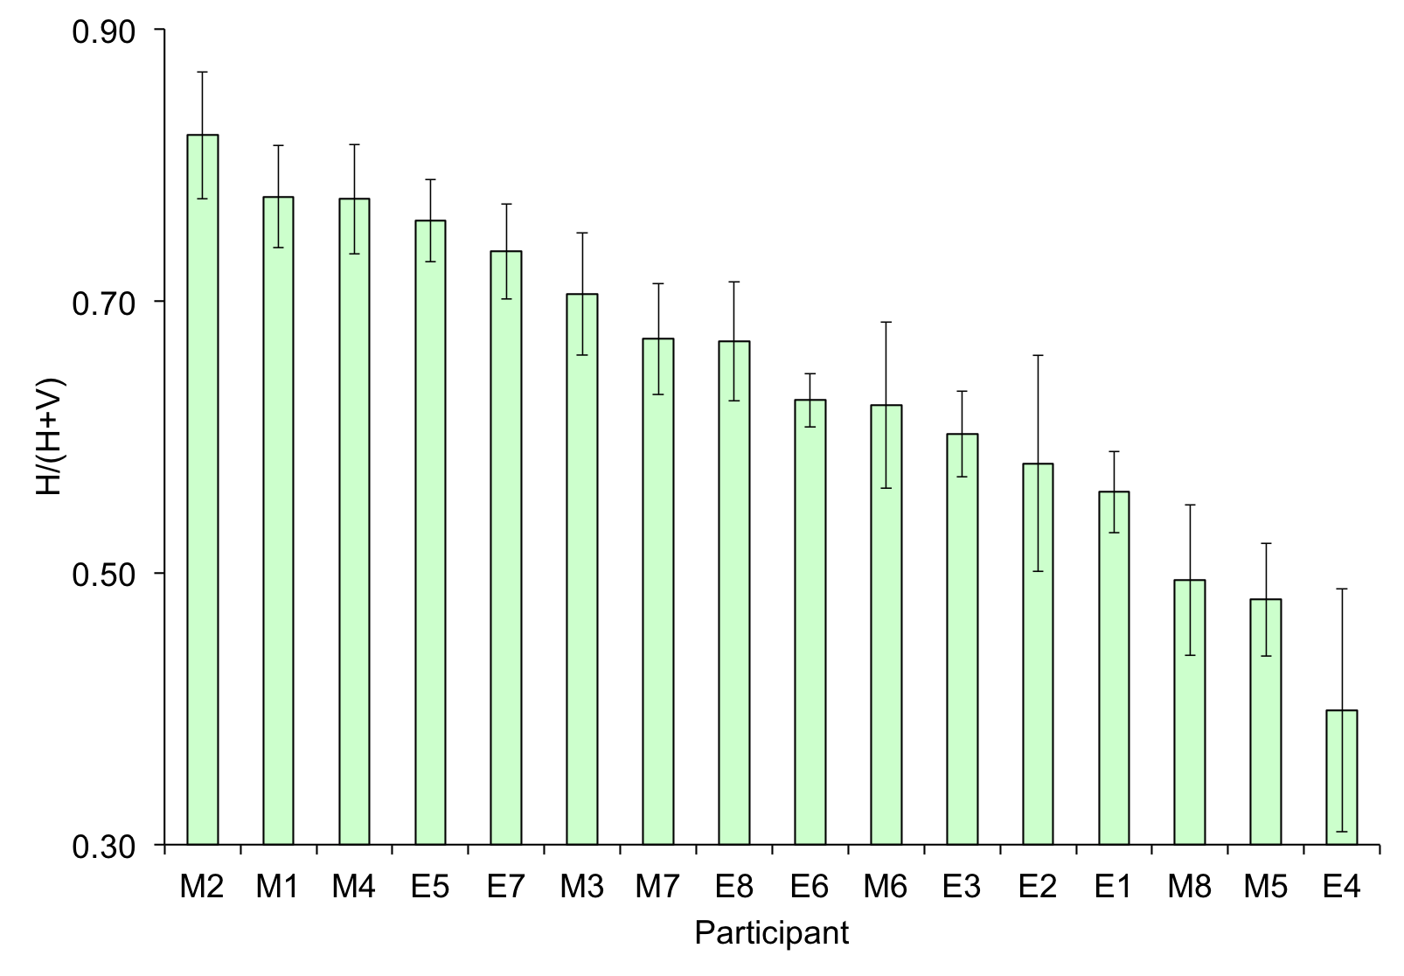
Figure 2: Mean H/(H+V) values for each participant (M represents participants with mathematics degrees, E represents undergraduate engineering students). Error bars show ±1 SE of the mean.

Second, we investigated whether participants’ strategy choices varied systematically by problem-type, mathematical background or success-rates. We first subjected H/(H+V) values to a 2×2×2 ANOVA with two within-subjects factors (quadratic/linear and recognisable/unrecognisable) and one between-subjects factor (mathematics/engineering). As shown in Figure 3, none of the main effects or interactions reached significance, indicating that there appeared to be no relationship between a person’s mathematical background, or the problem-type and their strategy choice. We had assumed, from our own experience with such tables, that the proportion of horizontal and vertical moves might differ between novices and experts.
In the early stages of our analysis we re-categorised subjects as successful/unsuccessful to distinguish between the eight participants who managed to find 7 or 8 functions and the eight who succeeded in fewer than 7 cases. We then repeated this analysis but replaced the group factor with this split-half success factor. Again, no main effects or interactions reached significance.
To summarise these findings, we found that there were substantial and systematic individual differences in strategy choice during generalisation problems. However, these strategy differences appeared not to be related to participants’ mathematical backgrounds, their success at solving the problems or the type of problem they were solving. An obvious question emerges: what does determine what strategy a participant adopts when tackling such problems?
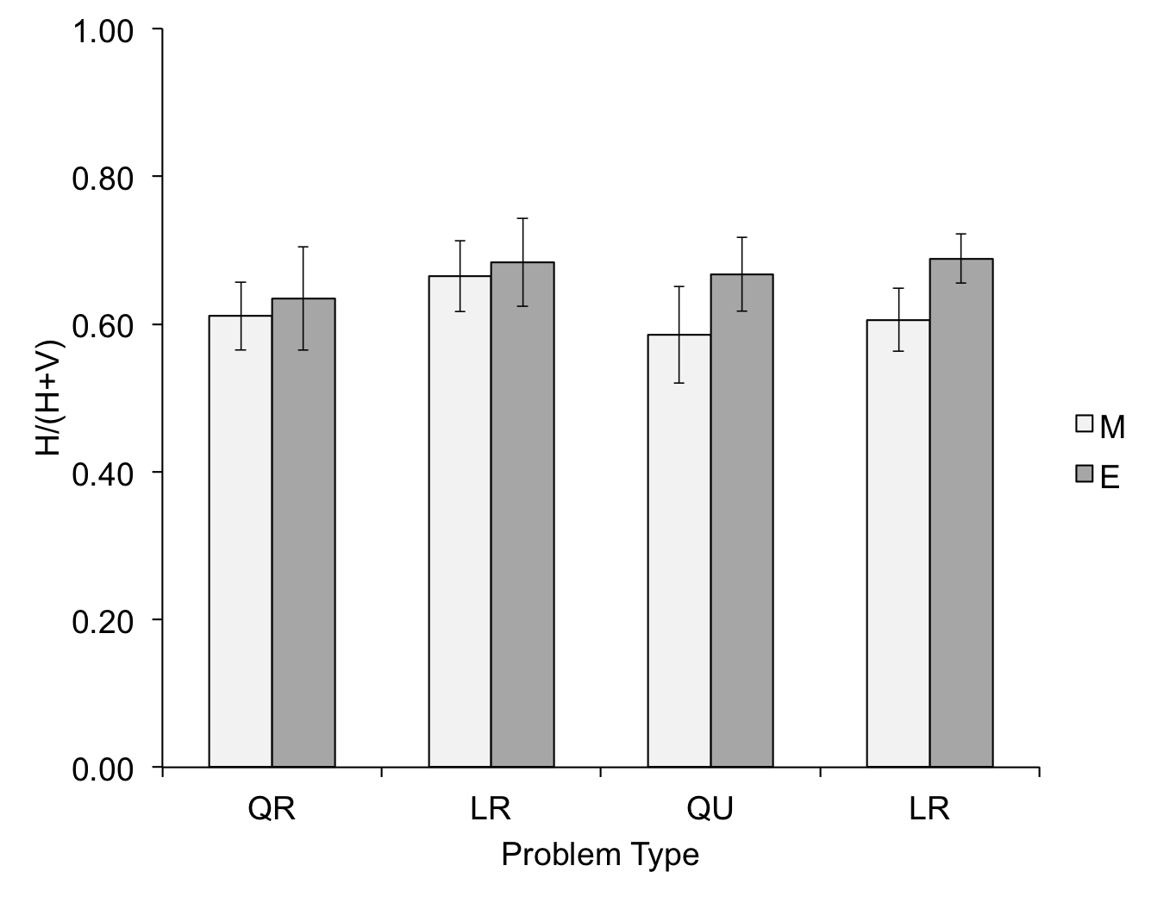
Figure 3. Mean H/(H+V) values by problem-type (Q-quadratic, L-linear, R-recognisable, U-unrecognisable), and mathematical background (M-maths degree, E-engineering u/g). Error bars show ±1 SE of the mean.

Future work
Further analysis of this data will be undertaken to identify the presence of strings of fixations which might indicate the collection of particular data, such as special values, or repeated passes between the same two points, or dwelling on particular positions.
To search for more information about strategies for using data to generalise, we intend to remove first the vertical component of movement by randomly presenting data as ordered pairs, and then to remove the horizontal association of n and f(n) by presenting f(n) values as horizontal sequences. We emphasise, however, that we are not suggesting that eye-tracking can present the whole story of such generalisations.

References
Andrà, C., Arzarello, F., Ferrara, F., Holmqvist, K., Lindstrom, P., Robutti, O. & Sabena, C. (2009). How students read mathematical representations: An eye tracking study. In Tzekaki, M., Kaldrimidou, M. & Sakonidis, C. (Eds.). Proceedings of the 33rd Conference of the International Group for the Psychology of Mathematics Education, Vol. 2, pp. 49-56. Thessaloniki, Greece: PME.
Cowen, L., Ball, L. J., & Delin, J. (2002). An eye-movement analysis of web-pagen usability. In X. Faulkner, J. Finlay, & F. Détienne (Eds.), People and Computers XVI—Memorable yet Invisible: Proceedings of HCI 2002 (pp. 317-335). London: Springer-Verlag Ltd.
Goldberg, H. J., & Kotval, X. P. (1999). Computer interface evaluation using eye movements: Methods and constructs. International Journal of Industrial Ergonomics, 24, 631-645.
Goldberg, J. H., Stimson, M. J., Lewenstein, M., Scott, N., & Wichansky, A. M. (2002). Eye tracking in web search tasks: Design implications. In Proceedings of the Eye Tracking Research and Applications Symposium 2002 (pp. 51-58). NY: ACM Press.
Gould, J. (1973) Eye movements during visual search and memory search. Journal of Experimental Psychology 98(1) 184-195
Just, M. A., & Carpenter, P. A. (1976). Eye fixations and cognitive processes. Cognitive Psychology, 8, 441-480.
Martinez, M. & Brizuela, B. (2006) A third grader’s way of thinking about linear function tables. Journal of Mathematical Behavior 25, 285-298
Poole, A. & Ball, L. (2006) Eye tracking in human-computer interaction and usability research: Current status and future prospects. In C. Ghaoui (Ed.): Encyclopedia of Human-Computer Interaction. Pennsylvania: Idea Group, Inc
San Diego, J., Aczel, J., Hodgson, B., Scanlon, E. (2006) There’s more than meet sthe eye: Analysing verbal protocols, gazes and sketches on external mathematical representations. In Novotná, J., Moraová, H., Krátká, M. and Stehlíková, N. (eds.). Proceedings of the 30th Conference of the International Group for the Psychology of Mathematics Education, Vol. 5, pp. 17-24. Prague, PME.
Warren, E., Cooper, T. & Lamb, J. (2006) Investigating functional thinking in the elementary classroom: Foundations of early algebraic reasoning. Journal of Mathematical Behavior 25, 208-223.

