Overcoming the Algebra Barrier:

being particular about the general, and

generally looking beyond the particular,
in homage to Mary Boole
John Mason
Oct 2015
Algebra consists in preserving a constant, reverent,
and conscientious awareness of our own ignorance [p56]
Teaching involves preventing mechanicalness
from reaching a degree fatal to progress [p15]
The use of algebra is to free people from bondage [p56]
[all quotes are from Mary Boole, extracted in Tahta 1972]

Abstract
Consistent with a phenomenographic approach valuing lived experience as the basis for future actions, a collection of pedagogic strategies for introducing and developing algebraic thinking are exemplified and described. They are drawn from experience over many years working with. Attention is mainly focused on invoking learners’ powers to express generality, to instantiate generalities in particular cases, and to treat all generalities as conjectures which need to be justified.

Introduction
That algebra is a watershed for most learners is common experience, and this has been the case ever since algebra emerged. It has long been my claim that school algebra is fundamentally the expression of generality in a succinct form so that it is easily manipulable (Mason, Graham & Gower 1985). The fact that almost all books on algebra (or arithmetic with algebra) since the 15th century have introduced algebra as the manipulation of letters as if they were numbers suggests that recognition of algebra as expression of generality seems so obvious as not to require mentioning, while what teachers want students to achieve is facility in manipulating algebraic expressions. Or it could be that the constant pressure to get learners to perform, to carry out procedures, has blinded curriculum designers to the essence of algebra.
It was Isaac Newton (1683) who diverted attention from the expression of generality to the nuts and bolts of algebraic manipulation, namely the solving of equations, though some of his contemporaries questioned whether expressing generality was as straightforward and simple as he claimed (Ward 1706). Pushing learners immediately into solving equations (first linear, then quadratic then perhaps factored or factorable polynomials and perhaps then into iterative methods for approximate solutions) is a reflection of the technician’s approach, the result of a particular transposition didactique (Chevallard 1985). But why would learners want to internalise a collection of procedures involving entities that have no meaning for them? My claim has always been that unless learners appreciate where equations come from, unless they comprehend the origins of equations and inequalities in the expression of generality, algebraic expressions and algebra itself will remain a mystery, and a watershed.
That algebra as the manipulation of letters is mysterious has been attested to by generations of learners concerning their experience at school. Many claim that they could do what was asked, but had no idea what it was about or why they were doing it. Recent generations have become less willing to undertake what seems to them meaningless, resulting in algebra continuing as one of the major watersheds of school mathematics.
Yet there is abundant evidence that young children can cope with abstraction, even with symbols for the as-yet-unspecified. Weakness in algebraic manipulation comes, I claim, not from insufficient practice, but from teachers concentrating on manipulation rather than invoking and evoking learners’ natural powers to specialise and to generalise, to see the general through the particular and to see the particular in the general (Mason & Pimm 1984).

Methods
I am interested in what is possible, happy that others are concerned to research what is the case currently in their situation. Furthermore, I am interested in lived experience, and as such I am committed to taking a phenomenological stance. Thus in this chapter the reader will find numerous mathematical tasks through and by means of which it is possible to get a taste of the more general claims that I am making. I am convinced that this is the best way to work with learners and colleagues: to offer experiences which can form the basis for noticing what might previously have passed by un-noticed, thereby sensitising oneself to notice opportunities to support and promote others becoming aware of something similar for themselves. This has been the basis for Open University courses for teachers since 1982 (Open University 1982; Mason, Graham, Pimm & Gower 1984), and as a foundation for research is elaborated in Researching Your Own Practice: the discipline of noticing (Mason 2002).
I offer no programme, no recommended or researchable sequence of tasks that will prove to be most effective. Rather my approach is to work on developing sensitivities to possibilities so that potential actions come to mind (actually, come to action but are considered before being enacted) in the moment when they are needed. Thus the teacher can be attending to what learners are saying and doing, rather than to a prepared sequence of tasks. This is in line with the notion of teaching by listening (Davis 1996).

Being Particular about the General
The suggestion in this section is that being particular about invoking and evoking generality, placing the expression of generality at the heart of the curriculum (and not simply in mathematics) would benefit many learners who for some reason or other, seem to leave their natural powers at the classroom door. There is extensive research backing up this proposition stretching over many years. See for example Giménez, Lins & Gómez (1996); Bednarz, Kieran & Lee (1996); Chick, Stacey, Vincent & Vincent (2001); Mason & Sutherland (2002); Kaput, Carraher & Blanton (2008); Cai & Knuth (2011).

Beginning in the earliest years
Mary Boole finds the origins of algebra in young children’s experience such as that a metal teapot can be hot or cold: some of its attributes can vary (Tahta 1972 p 57-58). Even earlier in a child’s life, in order to recognise mother in her various guises, with different smells and appearances, it is necessary to generalise, to recognise that some attributes can change while others remain invariant. This applies in the affective-emotional domain just as it does in the physical-enactive domain, and the cognitive-intellectual domain. Indeed, as Caleb Gattegno (1988) claimed, the foetus in the womb already shows signs of generalising, responding to different stimuli in particular ways.
To learn to read people’s expressions, to learn to grab and put things in your mouth, to crawl, to stand, to walk and to talk all require extensive and wide-ranging use of their natural powers to specialise and generalise. It has often been said that, given our success at teaching children to read and write, it is a good thing we don’t have to teach children to talk as well. Put another way, having used and developed their natural powers so well before they reach school, how might we call upon those same powers to develop further so that reading and writing, counting and arithmetic, algebra and conceptual thinking are just as natural? Terezinha Nunes & Peter Bryant (1996) (see also Nunes, Bryant & Watson 2008) show clearly how making use of what children bring to school in the way of experience and internalised actions can make a substantial difference to the children’s experience and success in school.
Western approaches have been strongly influenced by the staircase metaphor for learning, in which learners gradually ascend a staircase of ‘levels’ from the simple to the complex, from the particular to the more general, from the specific to the abstract. This permeates the curriculum and the pedagogy. By seeing Bruner’s trio of presentations (enactive, iconic, symbolic) as a sequence, rather than as three worlds of experience between which we move as we add layers of appreciation, comprehension and hence understanding, learners have often been enculturated into a sequence of always building from the simple to the complex, the particular towards the general, the concrete towards the abstract. Because this is how we teach, many learners balk at some stage and so do not experience the general, the abstract, the over-view. They remain locked into the specifics of procedures without appreciation of what is possible, without comprehension of what can be achieved, and without understanding of what their actions are all about. Mary Boole warned against this, but generations of learners are still having the experience of “hopeless non-comprehension”, or even of “self-protecting and contemptuous non-attention”. Tahta 1972 p51] She recommended “build[ing] up good habits on a basis within which falls the centre of gravity of the individual with whom you are dealing with.” [Tahta 1972 p17]
A contrasting approach has been promoted by Vasily Davydov (1990) and taken up by Jean Schmittau (2004) and Barbara Dougherty (2008), among others, who have shown that young children are perfectly capable of working from abstractions and generality to instantiation in particular situations.
An intermediate stance is both possible and desirable: sometimes starting from particulars, sometimes from a slight or moderate generality, and sometimes from an extremely general statement. Learners are then encouraged, whenever they are stuck, to specialise to examples with which they are more confident, and then re-generalise as they begin to make sense of the underlying structure. The purpose of specialising is not to fill a notebook with examples, but rather to detect and try to express underlying structural relationships.
This process was summarised as a pedagogic strategy and as a learning strategy in Open University 1982) see also Mason & Johnston-Wilder 2004) as a continuing spiral of Manipulating – Getting a sense of – Articulating – Manipulating – Getting a sense of – Articulating – … . This means turning to confidence-inspiring entities, manipulating them by seeking structural relationships, getting a sense of what is going on, and trying to articulate this, eventually reaching a succinct articulation which can form the basis of confidently manipulable objects in the future. When things get sticky, or thinking breaks down, you can move down the spiral to reach some confidently manipulable examples from which to re-ascend. This is basically what Hilbert is reported to use as his method (Courant 1981). | 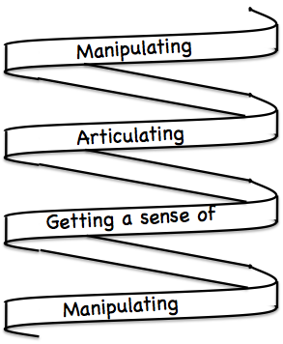
Since encounters with number, from the earliest moments, effectively draws on or makes use of the powers that enable abstraction and generality, working on getting learners to express generality in words, frequently, whenever appropriate, makes an important contribution to the developing of mathematical thinking. You cannot appreciate and comprehend arithmetic without encountering the general (Hewitt 1998).

Routes into Symbols
This section describes a collection of pedagogic strategies and didactic tactics which have been used to ease learners into the use of letters to denote the as-yet-unknown or the general. A plausible conjecture is that it is the sudden introduction of ‘letters in place of numbers’ which, for learners unused to denoting the as-yet-unknown, triggers refusal to cooperate in algebra, or, for many who appear to cooperate, brings down the portcullis on pursuing mathematics because of the meaninglessness of symbol manipulation.

Watch What You Do & Say What You See
When seeking how to locate and-or extend a repeating geometrical pattern, or a numeric pattern with some growth structure, it is often useful to ‘do an example’, preferably a non-trivial example, or even to ‘do’ several examples. This has been the practice since recorded time! While drawing or calculating, it can be useful to pay attention to what your body wants to do. For example, shown below are two configurations of squares made up of sticks, the first showing three rows of four columns and the second, four rows of six columns.
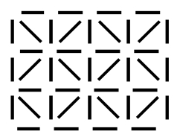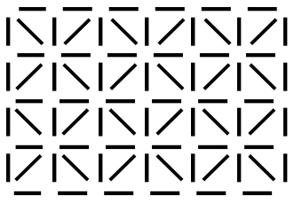
Make a copy of the second, watching how your body does the drawing. Then try to express how your body worked as a rule for how to draw a configuration with r rows and c columns, and how to count the number of sticks required.
The act of copying, or constructing your own instance, often leads to recognition of structure which can then be expressed verbally. Once refined, this provides a way to count the number of elements which can then be recorded using succinct symbols. For example, locating features in the first diagram which relate to three-ness and four-ness for which the same features in the second diagram relate to four-ness and six-ness is usually an acknowledgement by cognition of bodily awareness.
It is often the case that our bodies, our automatic functioning, locks into a pattern. For example, if invited to copy and extend the following for another nine rows,
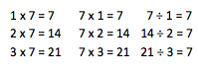
most children will quite spontaneously follow a flowing pattern downward, making use of the natural numbers and the invariants in each column. Anne Watson (2000) coined the expression “going with and across the grain” to summarise what is made available to be learned in such a situation. To complete the mechanical part of the task, go with the grain, following the downward flow; to make sense of it, ask yourself what is changing and what is invariant, and how the three statements in a row relate to each other. This is ‘going across the grain’, revealing the structure just as when you saw across the grain of a log you reveal the fibrous structure of the tree from which it came.
The slogan Say What You See (SWYS) can serve as a reminder to get learners to do articulate what they notice, first to a neighbour or group in which they are working, and then in plenary, where what is noticed can be recorded and organised. Once integrated into a learner’s functioning, SWYS can be a powerful aide to detecting and expressing structure.

Tracking Arithmetic
Tracking Arithmetic is a label for the act of following one or more numbers through a sequence of calculations, in order to see what their role is, their influence, their contribution to the result. In other words, it leads directly to perceiving structural relationships and expressing generality. An especially powerful example is given by the following collection of tasks.

THOANs
Think of a Number ‘games’ have been played for hundreds, perhaps thousands of years. A simple version is the following:
Think of a (positive whole) number; add two; multiply by the number you first thought of; add one; take the (positive) square root (I can assure you that if you started with a positive whole number you will have a whole number square root). Subtract the number you first thought of. Your answer is 1.
Offered a sequence of these, perhaps using only addition and subtraction, children soon want to know how it is done, and to try it themselves. Tracking arithmetic reveals the underlying idea:
Start with 7. Add 2 to get not 9 but 7 + 2. Multiply by the number you first thought of to get 7(7+2). Now add 1 to get 7(7+2)+1. I can do the arithmetic to discover 64 whose square root is 8, but I want to see that 8 in terms of the 7, and I can see that 7(7+2)+1 = 7 x 7 + 2 x 7 + 1 = (7 + 1)(7 + 1), so the square root is 7 + 1. Subtracting the number first thought of yields 1 as claimed. The 7 has been made to disappear! Now replace every instance of the starting 7 with a cloud (it might be that 7 also shows up in the calculation so one has to be wary):
Using a cloud, which draws upon learners’ experience of cartoons, has in my experience enabled algebra–refusers in secondary school both to engage and to act algebraically, blissfully unaware that they have been ‘doing algebra’. A good deal of the energy exhibited by learners who have chosen to become algebra–refusers lies in their not knowing what the letters of algebra refer to. As Mary Boole put it, the use of algebra is to free people from bondage (Tahta 1972 p55; italics in original), by which she means bondage by and to the particular.
A particularly effective use of tracking arithmetic can be made by tracking all numbers in the following task.

Grid Sums
Write down four numbers in a two by two grid (as in the example). | 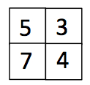
Record the products along the rows and the products down the columns.  Now add the column sums and subtract both the row sums. | 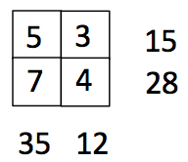
The result in this case is 35 + 12 – 15 – 28 = 4
Now choose four numbers in the grid so as to make the result equal to 3 (or any other pre-assigned number!).
Most people start trying numbers and doing calculations. Tracking arithmetic reveals an underlying structure:
The row sums are 5 x 3 and 7 x 4; the column sums are 5 x 7 and 3 x 4 so the result is
5 x 7 + 3 x 4 – 5 x 3 – 7 x 4 = (5 x 7 – 5 x 3) + (3 x 4 – 7 x 4) = 5 x (7 – 3) + (3 – 7) x 4
= 5 x (7 – 3) – (7 – 3) x 4 = 5 x (7 – 3) – 4 x (7 – 3) = (5 – 4) x (7 – 3)
The result is the product of the differences along the diagonals! Once that structure is recognised, it is easy to achieve any pre-assigned result, whereas without it, achieving a specified number can be really challenging. Of course if you are already familiar and confident with using letters, you can do it ‘algebraically’, but Tracking Arithmetic is available even if you do not yet have algebraic facility. Notice however that you do need some general arithmetic facility, which is why it is worth, early on in arithmetic, drawing attention to the properties of arithmetic such as commutativity, associativity and distributivity.
As an extension, why does the result stay the same if I choose two numbers, add the first number to the upper left and lower right cells, and subtract the second number from the lower left and upper right numbers?
Since no task is an island complete unto itself (Mason 2010), how might this task be altered or extended? It turns out that it is not obvious how to extend the idea to a three-by-three grid. However, there is a variation which might be somewhat surprising.
Reading clockwise from the upper left corner, form two two-digit numbers. In my case I get 53 and 47. Do the same counter-clockwise to get 57 and 43. Now form the difference of the products.
53 x 47 – 57 x 43 = 40
Adjusting the grid by subtracting say 1 from the main diagonal numbers and adding say 2 to the off diagonal numbers gives the grid shown, and  45 x 39 – 49 x 35 = 40 as well. Could this be a coincidence? | 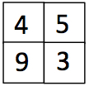
Tracking arithmetic on the original grid shows that
53 x 47 – 57 x 43
= (50 + 3) x (40 + 7) – (50 + 7) x (40 + 3)
= (50 x 40 + 50 x 7 + 3 x 40 + 3 x 7) – (50 x 40 + 50 x 3 + 7 x 40 + 7 x 3)
= (50 x 7 + 3 x 40) – (50 x 3 + 7 x 40)
= 50 x (7 – 3) + (3 – 7) x 40
= (50 – 40) x (7 – 3)
= 10 x (5 – 4) x (7 – 3).
It is immediately evident then that adding or subtracting the same thing to/from the main diagonal numbers makes no difference, nor does adding or subtracting the same number from the off diagonal elements. Furthermore, the result must always be 10 times the result of the previous calculation using the grid numbers. To ‘see’ this for oneself requires only locating the 5, 4, 7 and 3 in the grid itself, and realising (making real for oneself) that the digits are acting as placeholders and can be changed.

Acknowledging Ignorance
Mary Boole (see Tahta 1972 p55) suggested that algebra arises from “acknowledging ignorance”. When you recognise that you do not know ‘an answer’ you can acknowledge that fact by using a symbol (a little cloud is particularly effective) to denote what is not known. You can then use that cloud to express what you do know, and this will usually lead you to some constraints on the generality of ‘cloud’ in the form of equations or inequalities. Of course there are circumstances where this does not help, but these are rare in school algebra examinations!
I have written down two numbers whose sum is one. I square the larger and add the smaller; I square the smaller and add the larger. Which of my two numbers will be the larger?
Notice that strong force to try a particular example. Choosing 0 and 1, or 1/2 and 1/2 is not very revealing. The fact that the two calculations give the same result is, at least at first, a little surprising. Acknowledging our ignorance and denoting one of the numbers by and the other by is already using the cloud to express what you know, namely that they sum to 1. Now the calculations can be done using the cloud. If learners are not yet ready for manipulating cloud, than tracking arithmetic can be used:
Try 7 as one number, and 1 – 7 as the other (notice that any calculation involving 7 is indicated but not carried out. Then the two calculations give
=
and =
So the two calculations are equal in this instance.
But treating the 7 as a place holder rather than as a particular number, perhaps at first replacing it by a little cloud, confirms that the two calculations always give the same result. It is worth pausing and contemplating the scope or range of generality. The 7, or the cloud, can be replaced by any number you can think of, or indeed numbers you cannot even think of or which have never previously been thought of!
A useful task for emphasising the scope and range of generality involves variants of the following:
Write down a number between 3 and 4;
Now write down a number between 3 and 4 but which no-one else in the room will write down;
Now write down a number between 3 and 4 but which no human being is ever likely to have written down!
The second version draws attention to the range of possible choices. The third version sharpens awareness that there are more numbers than human beings have ever used! The idea is to draw attention to the range of possible variation, the scope of generality.
Note that in a task like this there is an opportunity to get a learner to choose what the difference will be. That way they have a sense of both the 3 and the 4 as place holders for a dimension of variation (a generality) as well as experiencing greater commitment to the task because they have participated in making a significant choice.
A related tactic is to make a guess, and then check whether your guess is correct. If you can check the correctness of a guess, then you can use tracking arithmetic to follow the guess through the checking process, using a little cloud or other token, and end up with equations and inequalities which express the constraints on the generality of your ‘guess’. The method of false position which pervades arithmetic books up until the 19th century is based on a way of making use of one or more guesses and the errors they give rise to when checking them, purely arithmetically, in order to determine the correct answer. This only works when the calculation is linear (one trial guess) or quadratic (two trial guesses), and rarely did authors of textbooks give any criteria for knowing whether one guess or two were required!

Word Problems
It has already been noted that if you can check the answer to a question, you can usually set it out algebraically, by Tracking Arithmetic: following your proposed answer through the calculations without losing track of it. Then you can set up the constraints on it as equations or inequalities, and perhaps even solve them to find the correct answer. This applies particularly to ‘word problems’. But asking learners to ‘solve’ word problems is likely to be met with hostility, whether cognitive, affective or enactive, and perhaps all three. However the notion of ‘burying the bone’, of trying to construct a problem that you yourself can do but that will challenge colleagues, perhaps even the teacher, can be used to increase engagement and disposition. Invoking the theme of ‘doing and undoing’, by asking learners to construct problems ‘like these’ which will challenge others, puts learners in the role of constructors, or meaningful agents. They may even come to appreciate the complexity of setting problems which will enable others to display their understanding, such as examiners. The more that learners get to make significant mathematical choices, the more likely they are to appreciate the tasks they are set, because they know how they are constructed and for what purpose.
Word problems can also be used to challenge people to find a solution without using algebra! Algebra becomes a backstop, a place of last resort. Meanwhile they are exercising their mathematical thinking in trying to find a purely arithmetic resolution. Then they can use Tracking Arithmetic to express a general formula for all problems of ‘that type’. This is how Newton (1683) presented his solutions: he solved a particular, then the general, and then showed that the particular was an instance of the general.

Reasoning Without Numbers
It is well worth while looking out for opportunities for learners to reason without having to work with numbers, especially if some or all have already developed a reluctance to master arithmetic.

Magic Square Reasoning
Imagine that the initial three-by-three square is covering up some three-by-three magic square. It doesn’t matter which one. The fact that it is a magic square means that the sum of the numbers in any row, any column or either diagonal are the same. So in particular, the sum of the numbers in the cells in the first row is the same as the sum of the numbers in the first column.
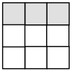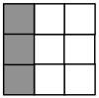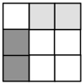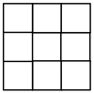
The sum of the light-shaded cells in the first grid is the same as the sum of the dark-shaded cells in the second grid, and because these would overlap, as shown in the third grid, the sum of the dark-shaded cells must be the same as the sum of the light-shaded cells in the third grid.
On the remaining grids, shade in sets of cells so that the sum of the dark-shaded cells must be the same as the sum of the light-shaded cells.
In the following grids, show why the sum of the dark-shaded cells must be the same as the sum of the light-shaded cells.
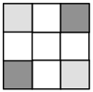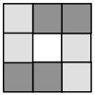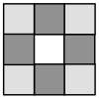
Notice that you do not need to know any of the numbers … the reasoning is all about rows, columns, and diagonals with overlaps removed. However, it is not always easy to see how to achieve someone else’s configuration. Things become even more challenging and hence interesting when you move to four-by-four or larger magic squares.
The power of the reasoning using overlaps is that the results apply to any magic square whatsoever, and yet numbers are not actually used. Learners find themselves thinking structurally, algebraically. Care is needed however, that learners keep in mind that the patterns they are using involve rows, columns and diagonals only, and a balance between the number of these in one colour and the number in the other colour, because these all have the same sum. In an experiment with children aged 11 it turned out that making patterns of colour dominated attention, and they lost the idea of using only rows, columns and diagonals and eliminating overlaps (Mason, Oliveira & Boavida 2012).

Reasoning About Numbers
Getting learners to reason about numbers, rather than doing arithmetic with them can encourage arithmetic-refusers to engage even though numbers are involved. For example,
I am about to subtract the number represented by the cloud (it is a number that someone is thinking about) from the number represented by the box (it is also a number that someone else is thinking about).
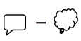
However, just before I do the subtraction, someone comes along and adds 1 to both of the numbers. How will the subtraction result change?
The invariance is both intuitive and readily justified. How can this task now be extended and developed? What aspects could be varied? Variation theory (see Marton & Booth 2005; Marton 2015) suggests that what is available to be learned is what has been varied in recent time and space. Teaching is seen as fundamentally about opening up dimensions of possible variation so that learners not only become aware of possibilities, but integrate into their functioning the action of considering what can be varied, and over what range and with what constraints (range of permissible change: see Watson & Mason 2005).
In this task, the adjustment by 1 is a dimension of possible variation, leading to the recognition that the same adjustment to both numbers will make no difference. Opening up the constraint that the adjustments must be the same leads to further insight. Altering subtraction to addition, to division or multiplication reveals similarities and differences in the language and the actions that preserve an invariance.

Generally Looking Beyond the Particular
Extending and varying, informed by variation theory are just as vital as getting answers to some task. The learner who arrives at a test or examination and who has treated every task as isolated, has to deal with each test item in its particularity, whereas the learner who has extended and varied, who has developed a rich space of examples and of ways to augment and modify examples, is likely to recognise the type of task and to have possible actions become available almost automatically. I have long encouraged learners about to take an exam to set their own exam and send it to the examiner, engaging in dialogue about what is reasonable and what is challenging, and why. In that way learners become acquainted with what testing is about, and develop their facility by extending and varying for themselves.
For example, the task One Sum presented earlier can be extended and varied in several ways, but most easily when the situation is depicted.
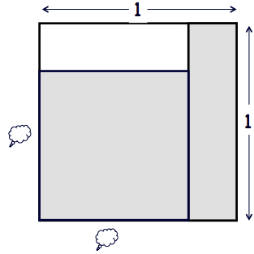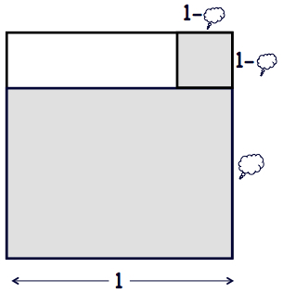
As often happens in mathematics, finding two or more ways to express the same thing can be enlightening and productive. Here the shaded area can be broken down in two ways, and this leads to other possibilities, taking the number of numbers adding to one as a dimension of possible variation, and taking the two-dimensionality as a dimension of possible variation.
Use the two diagrams below to express generalisations of the one-sum relationship.
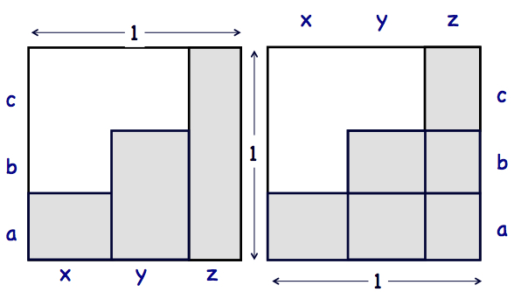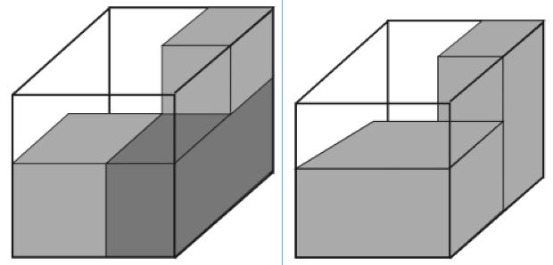
Working on expressing these involves both algebraic thinking, and shifting of attention back and forth from recognising relationships in the particular diagrams, and perceiving these as instantiations of properties (Mason 2001).

A Word of Caution
Just because some pattern or relationship can be extended, it does not mean that it is true. Put another way, every expression of generality starts life as a conjecture. It must be tested and justified. Even with elementary repeating patterns, care must be taken not to give learners the mistaken impression that whatever they think might be true, will be true.

Repeating Patterns
The following pattern is made from repeating a block of letters. Extend the sequence for yourself.
AAABAA
Of course there are several ways: the repeating block can be any of AAAB, AAABA, AAABAA, assuming that the generating pattern appears at least once. To make the pattern unique, it is mathematically necessary to know that the repeating pattern generating the sequence appears at least twice (Mason 2014). For example,
AAABAAAABAAAA
with at least two copies of the repeating pattern is uniquely identifiable and therefore extendable.

Power Sums
It is well known that , but not so well known that . Having checked this, it is hard to resist trying … but it doesn’t work!
The ‘obvious’ or ‘natural’ generalisation turns out to be false. The point is that the first two facts are not presented in a structural form which actually extends. If there is a suitable extension, some structural underpinning is required. That is why whenever learners are asked to extend a sequence, or to count the number of objects needed to make a term in a sequence, they must first be asked to articulate what the structural underpinning is that generates the sequence.

Structural Foundations
Consider for example the first two terms of a picture sequence:
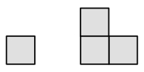
The third term could be any of the following
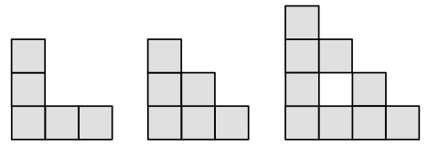
not to say something completely different. Without specifying how the diagrams are to be constructed, it is not possible to count the squares needed to make the nth picture.
Use of pedagogic strategies such as getting learners to consider, having resolved one problem, to consider the range of tasks they can solve similarly, and getting them to change what is given and what is sought (a manifestation of the mathematical theme of doing & undoing) not only engages learners more deeply, but offers them some actions to make use of for and by themselves, when studying, and when interacting with the world generally. Thus in the study by Jo Boaler (1997) learners at Phoenix Park, where mathematical thinking was encouraged through work on extended tasks, recognised the role of mathematics outside of the classroom in ways that students taught more traditionally as a sequence of procedures to be mastered did not.
Not only does extending or varying aspects of a task, exploring possible dimensions of variation, increase engagement with tasks, and not only does it provide ways for quicker learners to remain engaged, it is the very heart of mathematics, building up rich example spaces on which learners can draw in the future.
Even when you cannot see how to extend or vary, it is worthwhile trying. For example, I came across the following task in Pólya (1954 Ex. 7 p117-118) and included it in Mason, Burton & Stacey (1982 p p169). Pólya noticed it in our book and asked why we had associated his name with it, which was because we got it from him!

Pólya Strikes Out
Write out the natural numbers in a sequence
Circle every other number
Form the cumulative sums of the uncircled numbers.
Not too surprisingly, we get the square numbers. If instead you begin by circling every third number, forming cumulative sums, then circle every second number in this, and form the cumulative sums, you get another recognisable sequence. Repeating this sort of action continues to reveal recognisable sequences. Try as I might I could not get beyond a simple generalisation. Then John Conway & Richard Guy (1996 p63-65) found it in a paper of Moessner (1951: see Conway & Guy 1996 p89) and generalised it extensively. They noticed that if instead of using ‘every-something’ as the circling rule, you circle each number in a triangular-number position, repeatedly, then the first circled numbers in each row form another familiar sequence, and that is just the beginning!
The slogans “be wise, generalise” (attributed to Piccayne Sentinel: see MAphorisms) and “there is always something more to discover in the way of connections and relationships” are part of a mathematician’s creed, though it must also be noted that Paul Halmos (1975) decried the effect on graduate students of using the first without also being aware of instantiations of those generalisations, and of where in mathematics they might be relevant. William Blake also decried generalisation, claiming that “to generalize is to be an idiot”. I take the more balanced view that generalisation and instantiation in the particular are both important, in fact are inescapably intertwined, and that to focus on one without the other is indeed to be an idiot.

Classroom Ethos
For mathematical thinking to take place effectively, there has to be a conjecturing atmosphere (Mason, Burton & Stacey (1982/2010 p64, p233). This is so much a part of mathematicians’ practice that books often do not bother mentioning it. Yet it is fundamental. In such a classroom ethos, those who are confident about a question or a task listen to what others have to say, while those who are not confident try to say what they can. Things are said (by learners, by the teacher) in order to get them outside of the ‘tumble-dryer’ mind in which ideas get mixed up and change even in mid expression. Things are said as conjectures, in order to consider them dispassionately. Then, as George Pólya (1965) put it, “you must not believe your conjecture”.
Instead of disagreeing with what someone says, or telling them they are wrong, in a conjecturing atmosphere you might ask about how what was said plays out in … (and here an example, perhaps a potential counter-example is offered). Learners quickly find that asking someone to repeat what they said is less productive than trying to say what you think you heard, and asking for clarification.

Increasing Sums
Consider the portion of Pascal’s triangle shown below, and convince yourself you know how to extend it to the right and down.

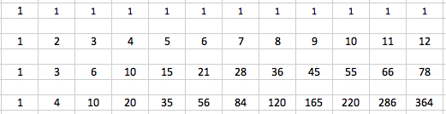
Now group as shown below
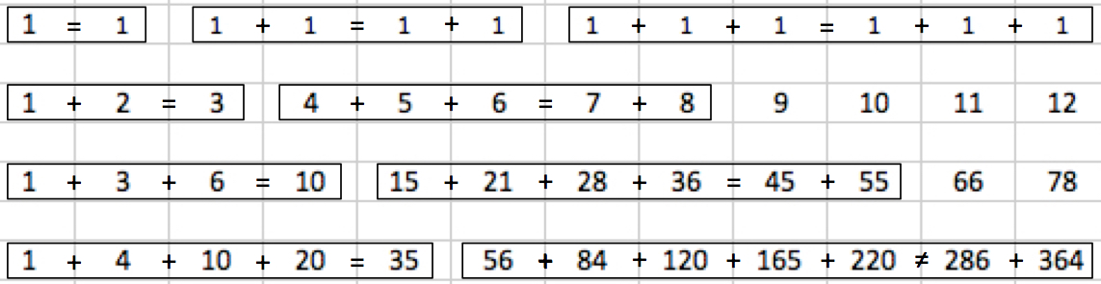
Say What You See in this diagram. Take your time. It might even help to make a copy for yourself, and Watch What You Do. Ask yourself what is invariant (not just objects, but relationships), and what is changing and in what way(s). What is the same and what is different about each row, about the groupings in each row, about the groupings in a sequence of rows?
The first row groupings seem trivial, but in retrospect from the second and third rows they make sense. But the fourth row display a counter-example to a common conjecture! A generalisation, an expression of generality, is always a conjecture until it can be justified!
Note the pedagogic strategies instantiated in the follow-up part of the task.

Summary
Drawing on more than fifty years of working with others to develop mathematical thinking, it seems clear to me that there is no royal road to teaching, no single track to pedagogy, no magic sequence of tasks that will achieve the transformation in thinking algebraically sought after for so many centuries by so many educators. Quite the contrary, it is all about sensitivity to individuals and to groups of individuals. It is all about teaching as a caring profession: caring for learners and caring for the subject matter. It is all about responding to particular situations with access to a rich repertoire of pedagogic strategies and didactic tactics. It is about nurturing like a gardener rather than managing an assembly line.
In this chapter I have offered some pedagogic strategies, some didactic tactics, and some tasks through which to encounter these, which, if handled sensitively and carefully, not as one-off events but as a classroom ethos, a way of working with others, could make a difference to succeeding generations.

References
Bednarz, N. Kieran, C. & Lee, L.(Eds.) (1996). Approaches to Algebra: perspectives for research and teaching. Dordrecht: Kluwer.
Boaler, J. (1997). Experiencing school mathematics: teaching styles, sex and setting. Buckingham: Open University Press.
Cai, J. & Knuth, E. (2011). Early Algebraization: a global dialogue from multiple perspectives. Heidelberg: Springer.
Chevallard, Y. (1985). La Transposition Didactique. Grenoble: La Pensée Sauvage.
Chick, H. Stacey, K. Vincent, J. & Vincent, J. (Eds.) (2001). The Future Of The Teaching And Learning Of Algebra, Proceedings of the 12th ICMI Study Conference, University of Melbourne, Melbourne.
Courant, R. (1981). Reminiscences from Hilbert’s Gottingen, Mathematical Intelligencer, 3 (4), p154–164.
Davis, B. (1996). Teaching Mathematics: towards a sound alternative. New York: Ablex.
Davydov, V. (1990). Types of Generalisation in Instruction. Soviet Studies in Mathematics Education Vol 2, NCTM, Reston.
Dougherty, B. (2008). Algebra in the Early Grades. Mahwah: Lawrence Erlbaum.
Gattegno, C. (1988 second edition). The Mind Teaches the Brain. New York: Educational Solutions.
Giménez, J. Lins, R. & Gómez, B. (Eds.) (1996). Arithmetics and Algebra Education: searching for the future, Barcelona: Universitat Rovira i Virgili.
Halmos, P. (1975). The Problem of Learning to Teach. American Mathematical Monthly. 82(5), p466–76.
Hewitt, D. (1998). Approaching Arithmetic Algebraically. Mathematics Teaching 163 p19-29.
Kaput, J. Carraher, D. & Blanton, M. (2008) Algebra in the early Grades. Mahwah: Erlbaum.
MAphorisms (accessed October 2015) www.math.ku.dk/~olsson/links/maforisms.html
Marton, F. (2015). Necessary Conditions for Learning. Abingdon: Routledge.
Marton, F. & Booth, S. (1997). Learning and Awareness. Hillsdale, USA: Lawrence Erlbaum.
Mason, J. Graham, A. Pimm, D. & Gowar, N. (1985). Routes To, Roots Of Algebra. Milton Keynes: The Open University.
Mason, J. , Graham, A., Pimm, D., & Gowar, N. (1985). Routes to, Roots of Algebra, The Open University, Milton Keynes.
Mason, J. (2002). Researching Your Own Practice: The Discipline of Noticing, Routledge-Falmer, London.
Mason, J. (2010). Attention and Intention in Learning About Teaching Through Teaching. In R. Leikin & R. Zazkis (Eds.) Learning Through Teaching Mathematics: development of teachers' knowledge and expertise in practice. p23-47. New York: Springer.
Mason, J. (2014). Uniqueness of Patterns Generated by Repetition. Mathematical Gazette. 98 (541) p1-7.
Mason, J. & Johnston-Wilder, S. (2004). Designing and Using Mathematical Tasks, Open University, Milton Keynes.
Mason, J. & Pimm, D. (1984). Generic Examples: Seeing the General in the Particular, Educational Studies in Mathematics, 15(3) p277-290.
Mason, J. & Sutherland, R. (2002). Key Aspects of Teaching Algebra in Schools. London: QCA.
Mason, J. 2001, Teaching for Flexibility in Mathematics: being aware of the structures of attention and intention, Questiones Mathematicae, 24 Suppl 1, p1-15
Mason, J. Oliveira, H. & Boavida, A. M. (2012). Reasoning Reasonably in Mathematics. Quadrante, XXI (2) p165-195.
Newton, I. (1683) in Whiteside, D. (Ed.) (1964). The Mathematical Papers of Isaac Newton, Vol V, Cambridge: Cambridge University press.
Nunes, T. & Bryant, P. (l996). Children Doing Mathematics. Oxford: Blackwells
Nunes, T. Bryant, P. & Watson, A. (2008). Key Understandings in Mathematics Learning. www.nuffieldfoundation.org/key-understandings-mathematics-learning (accessed Oct 2015).
Open University, (1982). EM235: Developing Mathematical Thinking. A distance learning course. Milton Keynes: Open University.
Pólya, G. (1954). Induction and Analogy in Mathematics. Mathematics and Plausible Reasoning. Vol 1. Princeton: Princeton University Press.
Pólya, G. (1965). Let Us Teach Guessing, (film). Washington: Mathematical Association of America.
Schmittau, J. (2004). Vygotskian theory and mathematics education: resolving the conceptual-procedural dichotomy. European Journal of Psychology of Education. 19(1) p19-43.
Tahta, D. (1972). A Boolean Anthology: selected writings of Mary Boole on mathematics education. Derby: Association of Teachers of Mathematics.
Ward, J. (1706). The Young Mathematicians Guide, being a plain and easie Introduction to the Mathematicks in Five Parts ..., London.
Watson, A. (2000). Going Across the Grain: mathematical generalisation in a group of low attainers. Nordisk Matematikk Didaktikk (Nordic Studies in Mathematics Education). 8 (1) p7–22.
Watson, A. & Mason, J. (2005). Mathematics as a Constructive Activity: learners generating examples. Mahwah: Erlbaum.

