Dose of Don: symmetry (Sudeep Gokarakonda)
This is a contribution to series of writings, begun by Anne Watson, which delve into the collection of tasks on Don Steward’s blog (https://donsteward.blogspot.com) and pull out threads about key ideas in mathematics that run through several of his tasks. Direct links to all tasks mentioned are included below.
Don was very generous with his tasks and it is hoped that you will return this generosity in the way he requested before he died, namely to donate to https://www.justgiving.com/fundraising/jessesteward
This post is about symmetry. Mention symmetry, and many people’s first thoughts might involve symmetry in a firmly geometric context. At school, almost all students explicitly encounter reflection and rotational symmetry. For many, their appreciation of symmetry might not extend beyond these ideas.
Symmetry is something that permeates mathematics, and it is something mathematicians can recognise in situations that aren’t presented in a typical geometric context. Here, for example, is such a situation:
You have the following coins totalling 70 pence. In these questions, “amount” refers to a whole number of pence.
- Using only these coins, what is the smallest amount you cannot make?
- Using only these coins, what is the largest amount under 70 pence that you cannot make?
- What do you notice about your two answers?
***
I remember a lesson involving Pascal’s triangle during which I causally mentioned its symmetry. One student appeared convinced that I was wrong to suggest any symmetry here. On exploring, I realised they were considering the numerals rather than the numbers, so for them:
- 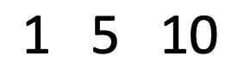 would have been symmetric;
- 1 5 10 01 5 1 would have been “kind of” symmetric; and
- 1 5 10 10 5 1 was definitely not symmetric.
This slightly constrained conception of symmetry was not totally surprising, knowing that the student’s exposure to the idea had been limited to the geometric contexts in the GCSE specification.
Here are some slides from Don’s tasks. Not one of the chosen tasks is primarily about symmetry. Nevertheless, each gives us opportunities to notice and explore symmetry.

mean of a frequency distribution
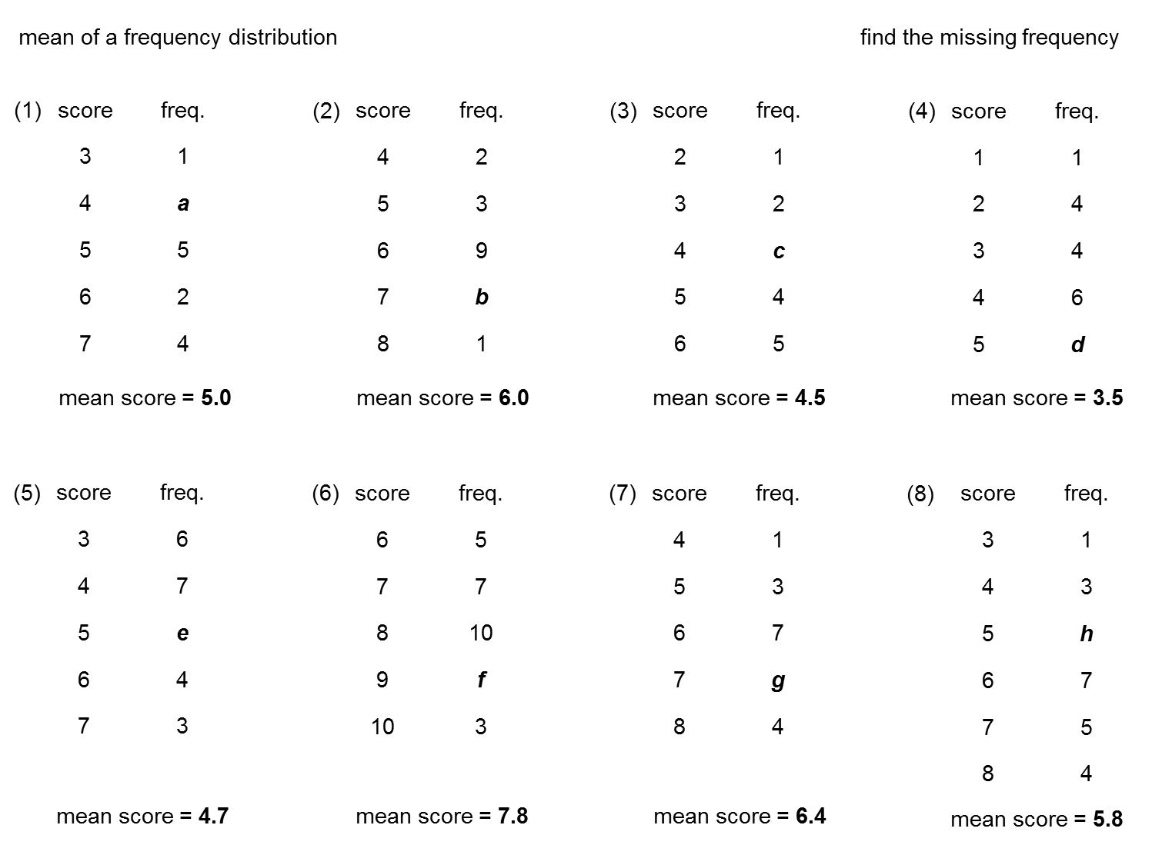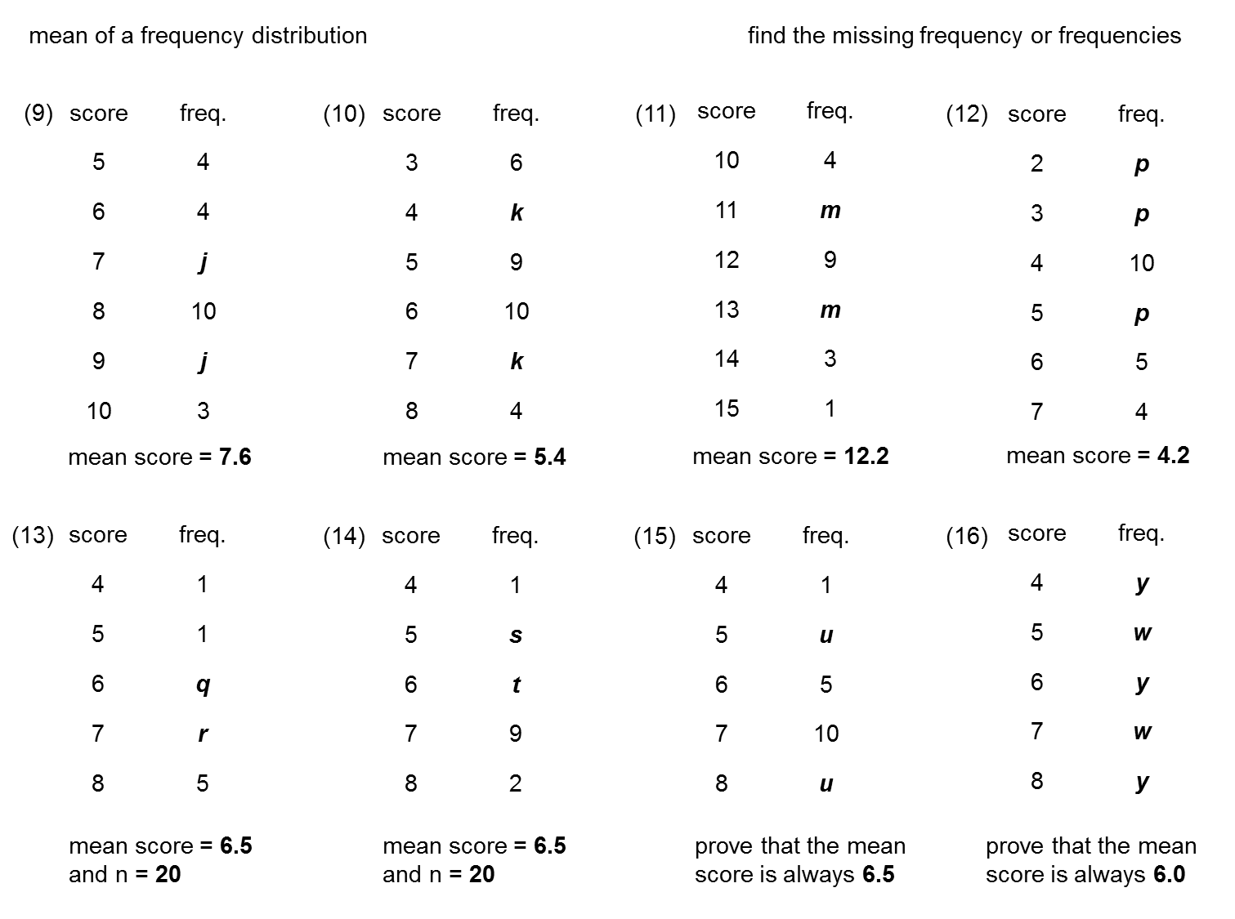
These are the first two slides from the task. Let’s consider question 16. The frequencies y, w, y, w, y read the same forwards and backwards. It is possible to prove that the mean is always 6 without spotting this, by setting up and simplifying the following:
$$mean=\frac{4y+5w+6y+7w+8y}{y+w+y+w+y}$$

But spotting the symmetry leads to a chance to generalise. In
question 16, if I replaced y, w, y, w, y with any symmetric sequence (e.g.) a, b, c, b, a, would the mean still be 6? If the frequencies were instead a, b, c, d, a but the mean was still 6, what could we conclude?
I also like tying question 16 back to questions 1 and 2 using an alternative approach—appreciating how scores below the mean must be perfectly “balanced out” by scores above the mean.
For example, in question 1, given that the mean is 5,
- the single score of 3 gives a “deficit” of 2;
- the scores of 5 have no impact on the mean;
- the two scores of 6 give a “surplus” of 2; and
- the four scores of 7 give a “surplus” of 8.
Overall, I therefore still need a further “deficit” of 8. Since a single score of 4 results in a deficit of 1, I need eight such scores, so a = 8.
This approach is, to me, is mentally less taxing than setting up and solving the following in my head:
$$\frac{(3×1)+4a+(5×5)+(6×2)+(7×4)}{1+a+5+2+4}=5$$
The “balancing out” approach of course works in all questions, but it’s perhaps best illustrated using those questions where the mean is an integer (i.e. questions 1, 2 and 16), because the arithmetic is kept relatively simple. I love how this section of the task can be bookended in this way.

geometry of the reciprocal function
This task includes five slides. Shown are the first four, which all feature the curve $y=\frac{12}{x}$.
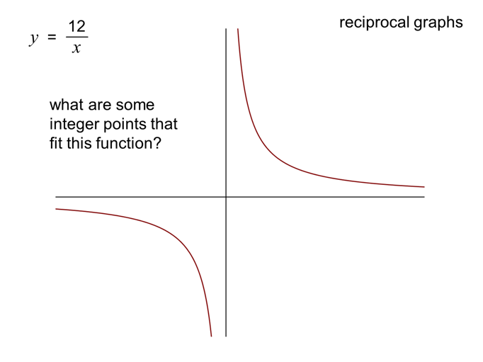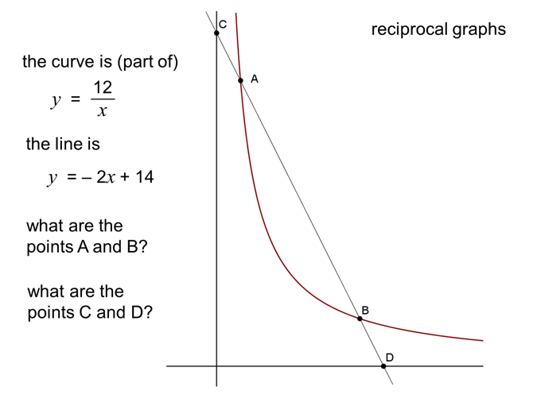
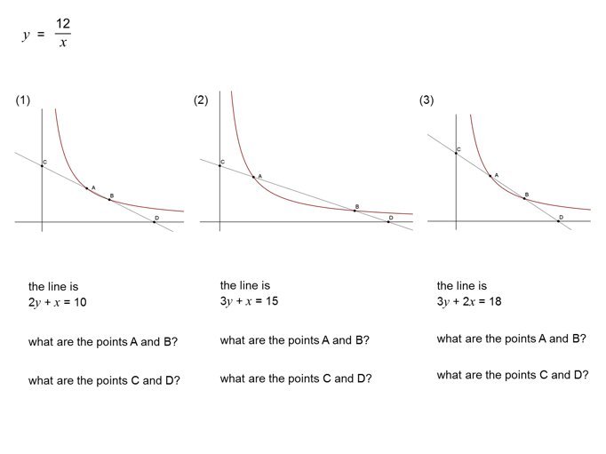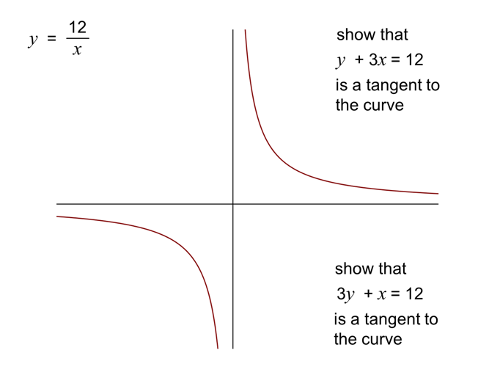

The line $y=x$ is a line of symmetry on all four slides—even where we only have the first quadrant. This line of symmetry may not initially be obvious to all students. On the very first slide, however, is the opportunity to spot that e.g. (1, 12) and (12, 1); (2, 6) and (6, 2) etc. are all points on the hyperbola. Is it necessarily the case that if (a, b) is on the curve, then so is (b, a)? What about (–a, –b)?
These questions involve symmetry in a geometric context, but an opportunity to consider symmetry in a more subtle context pops up on slide 4. I see that 3y + x = 12 is just y + 3x = 12 with the x and y swapped around. Without even seeing the graphs of these, I sense symmetry in these coefficients. Here is an opportunity to ask what happens, in general, to a graph if I swap x and y around in its equation. Students could make predictions, and then check by trying several functions using graphing software. Can they come up with an intuitive explanation for what they observe?
This moment may be a natural one to take a detour to visit (or revisit) self-inverse functions—or even sample another of Don’s tasks, such as self-inverse and periodic functions.

Visualising
The idea of symmetry crops up when considering arrangements, probabilities, and many topics in statistics. Don’s tasks often include beautiful yet simple visualisations illustrating symmetry:
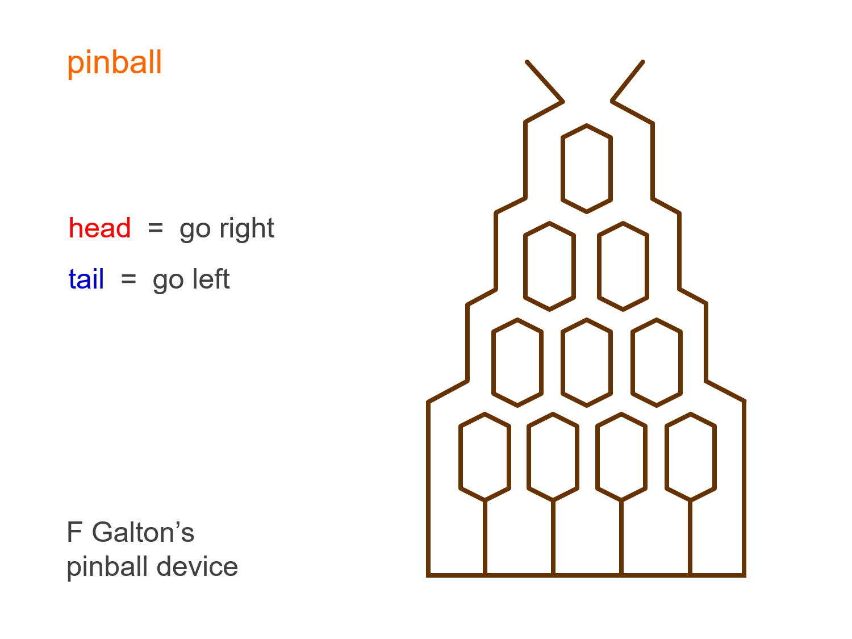  From Galton's quincunx | From Probability with coins
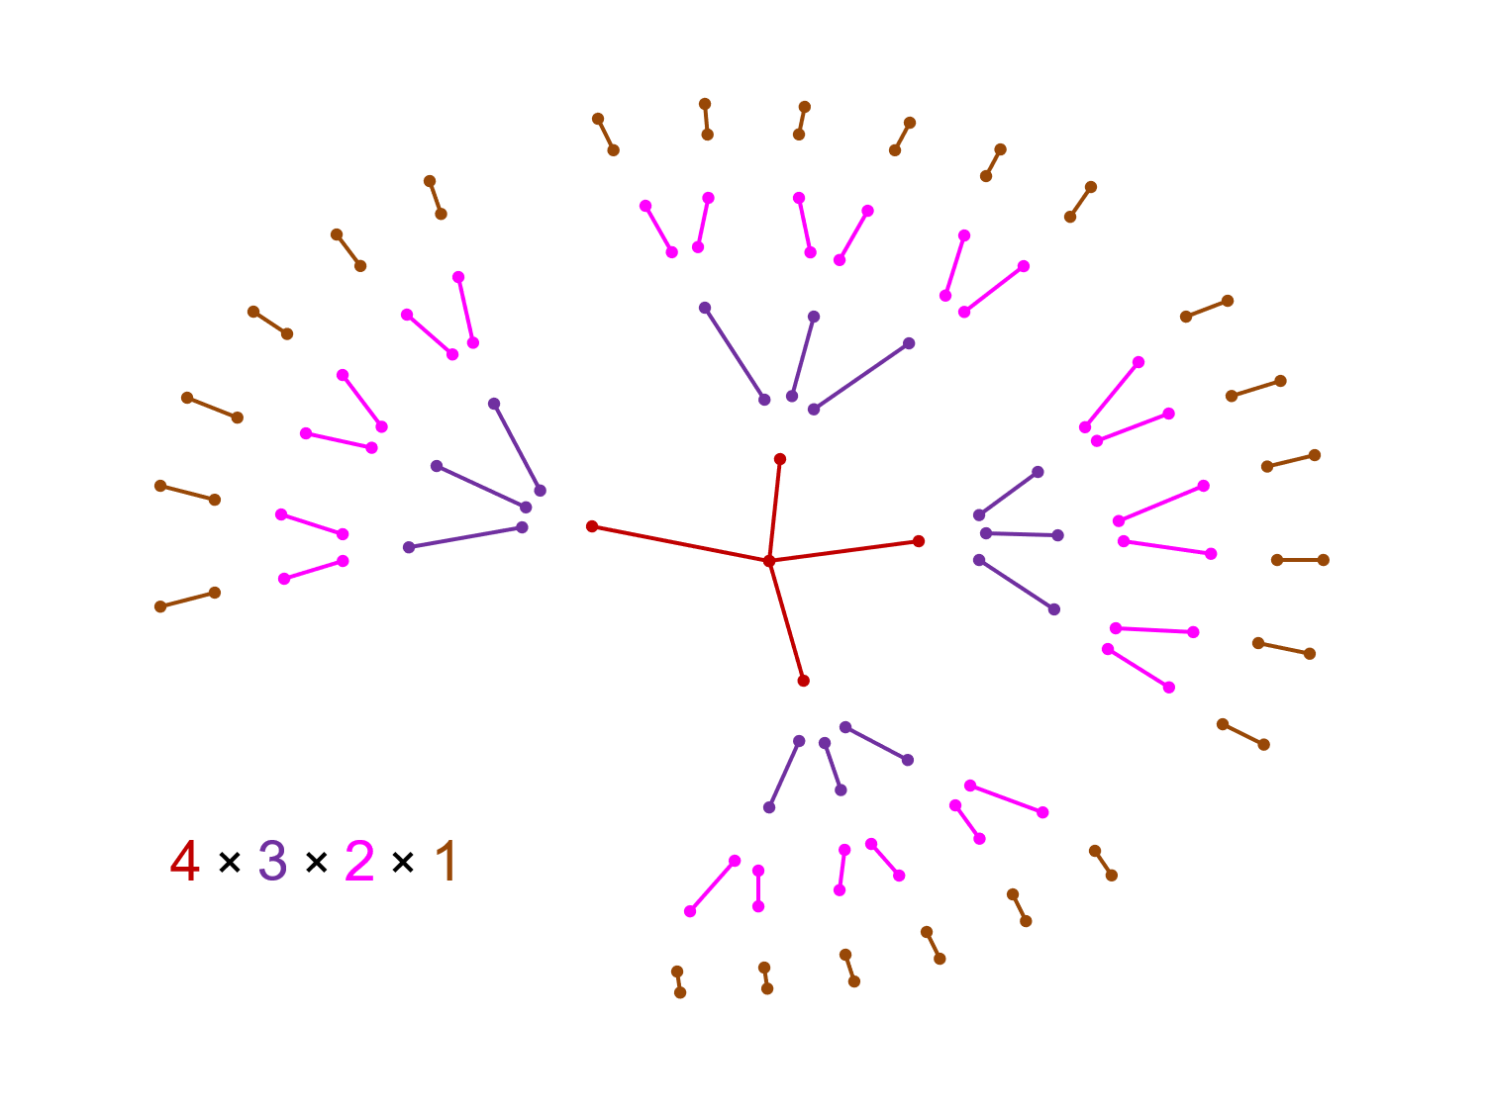
From Probability arrangements
What I like in this final diagram is that, as drawn, it does not have rotational or reflective symmetry. This opens the possibility to discuss what mathematicians might mean when talking about symmetry here. Such discussions should hopefully help broaden the kind of conception of symmetry exhibited by my aforementioned student of Pascal’s triangle.
***
As stated earlier, none of the above tasks are primarily about symmetry. Don created other tasks that I’ve not detailed here, where it is quite possible to work through them—and gain richly—without spotting the symmetries in them. But spotting them gives classes the opportunity to perhaps take a “scenic route” through the tasks—one that helps build up students’ sense of symmetry in mathematics.

