Signatures of Shapes

John Mason  
ATM 2016

### Introduction

For a circle with radius *r*, the area *A* =  and the semi-perimeter *s* = . The square of the semi-perimeter divided by the area is π. The radius *r* is the area divided by the semi-perimeter.

Define the *signature* of a two-dimensional shape to be .

Define the *shape-radius* of a shape to be  . Define the *shape-circle* of a shape to be the circle with centre at the centre-of-gravity of the vertices and radius the shape-radius.

### Way of Working

There follow a series of conjectures to be checked and modified as necessary. Statements in italics are definitions or comments. There is no need to complete work on one section before considering another.

### Rectangles

*All rectangles are specified either by their side lengths (largest first) in the form [a, b] or by* [*semi-perimeter, Area*].

*The shape-ratio of a rectangle is the ratio of the longest side to the shortest side.*

Amongst all rectangles, squares have the minimum signature.

The signature of a rectangle with edge lengths *a* and *b* is

where μ = *a* : *b* and so depends only on the shape ratio.

The shape-radius of a rectangle is  . The shape-circle of a rectangle can be constructed as follows:

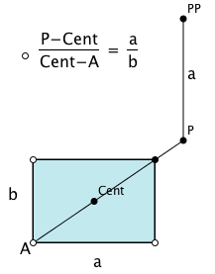 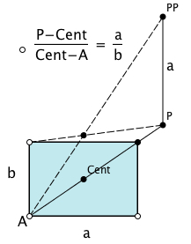 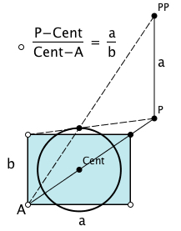 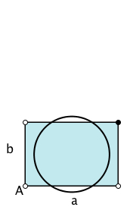

The shape-circle for a square is the incircle.

### Triangles

The signature of a right angled triangle is greater than or equal to .

Amongst all right-angled triangles, isosceles right-angled triangles have minimum signature.

Amongst all triangles, equilateral triangles have minimum signature.

Amongst all isosceles triangles, isosceles right-angled triangles have minimum signature.

The shape-circle of an equilateral triangle is the incircle; for a Pythagorean right-angled triangle with sides  ,  and the shape-radius is  .

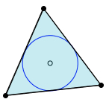 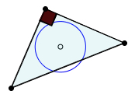 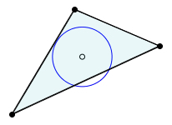

### Regular Polygons

The signature of a regular polygon is greater than π. As the number of sides increases, the signature decreases.

 where *n* is the number of sides.

The shape-circle of a regular polygon is the incircle.

### Rectilinear Shapes

*These are shapes made up by gluing rectangles together along edges: every edge is parallel to one of two edges; all internal angles are 90° or 270°.*

Two rectilinear shapes can have the same signature and yet not be similar.

### Challenges

The signature of any rectilinear shape is at least 4.

The signature of any shape is at least π.

## Notes Towards Resolutions

### Rectilinear Shapes

Making figures with the a given signature is relative easy using the ‘bite technique’:

Removing a corner from a rectangle leaves the semi-perimeter unchanged but reduces the area.

Thus the signature of a rectangle with area *A* and semi-perimeter *s* with a rectangle removed from one corner with area *B* is  independent of the semi-perimeter of the removed corner rectangle .

Similarly, starting with a circle, reflecting the minor arc subtended by a chord, in that chord, leads to a figure with the same perimeter but smaller area. Thus the signature can be adjusted to any desired value greater than or equal to π.

|  |  |
| --- | --- |
| Use a sequence of squares with a handle, so put  and  while  and  Forcing the areas and the semi-perimeters to be equal requires that  and    For example  , ,,  so putting , , , forces  and gives the examples on the right. |  |

### Challenge

Steiner famously used a reflection type argument to show that making a shape convex (reflecting across an external chord) decreases the signature; if there are two consecutive straight edges, making them equal in length using facts about triangles and preserving areas decreases the signature; replacing a straight edge by an arc of a circle decreases the signature.