Starting out:
Circumcentre: centre of circumcircle; intersection of perpendicular bisectors of sides of a triangle (chords of the intended circle)
Circle through three points: you may have a button that does this for you, but my advice is to construct it from realising that the three points are the vertices of a triangle and the circle you want is the circumcircle of that triangle. Find the circumcentre as above, then draw a circle with that centre and radius from the circumcentre to one of the midpoints – which you can find from the perpendicular bisector. You will need this a few times, so maybe practise.
Orthocentre: intersection of altitudes; drop a perpendicular from a vertex to its opposite side – repeat
Draw triangles using line segments, but you will often have to extend these into infinite lines when you start using altitudes or looking for intercepts. Keep the segments and the infinite lines so you can always see the original triangle but hide the infinite lines and construction lines.
There are 7 sequences of construction and although they are in a particular order for a reason it is also OK to jump about after sequence 3. Sequence 6 needs sequence 5 and is spectacular.

Sequence 1
Draw triangle ABC
Construct orthocentre and label it H (always change labels as you go to stay inline with what is used in these tasks and also in Dick’s booklet).
Hide construction lines
Join H to A, B and C
You now have 4 triangles
H is the orthocentre of triangle ABC
A is the orthocentre of …..
B is the …………. of ………
C?
Convince?
ABCH form an orthocentric set

Sequence 2
On the same diagram as sequence 1.
Construct the medial circle of ABC: the circle that goes through the mid-pts of the sides. You may need the construction lines and the circumcentre later on so use the method given at the start of this work. The mid-points would be the vertices of a triangle for which the medial circle is the circumcircle, so the mid-pts give you three chords of the medial circle.
Label the centre of the medial circle N.
Hide the construction lines because some of them will get in the way of the next bit, but some of them could be helpful (DO NOT DELETE or you will lose some of your work).
How does the medial circle of ABC relate to the medial circles of the other three triangles HAB, HAC, HBC? If you are going to draw all these you might want to un-hide and re-use some of your previous construction lines.
Convince?

Sequence 3
Maybe choose a different colour for this sequence. You might want to hide any construction lines and circles but keep the original points H,A,B,C (the orthocentric set) and the 4 triangles.
Using the same diagram as before: construct the 4 circumcentres. There are now lots of right angles around so you might not be surprised that these 4 circumcentres form an orthocentric set for 4 triangles that you have not drawn.
Construct the 4 triangles.
Test what you see by wiggling a vertices to get extreme or special cases.
You might wonder about medial circles too. Draw the medial circle for one of your 4 new triangles.
Test what you see to extreme cases.
Convince?
Save your work and start a new file for the next sequence.

Sequence 4
Start a new construction with a new name.
Draw triangle ABC
Construct the orthocentre (label it H) and the circumcentre (label it O) and the median point (label it M): intersection of lines from each vertex to mid-point of the opposite side. Hide all the construction lines so you can see what is going on.
Join HO with a line (not a line segment). OMH is a straight line with M trisecting OH.
Wiggle ABC about a bit. Is what I have just said still true? Convince?
OMH is called the Euler line.
[Dick’s proof is in the proof notes and I don’t yet (Feb 2021) understand it completely. However, because of the constructions you have done so far, and assuming that you know the median point is one-third of the median line segment, you might be able to show that the points O,M,H do indeed form a straight line trisected by M. Be careful not to assume they are in a straight line – I had to draw a pencil diagram in which they did not look like a straight line.]
FInd the mid-point of OH and label it N (a label you have seen before). You might like to change to a joyous colour. Draw a circle with centre N and radius its distance to the mid-point of a side. You have seen this circle before.
Join H to the vertices A,B and C and mark the mid-points of HA, HB, and HC. The circle you have drawn is famously known as the nine-points circle.
Look back at the previous construction file: does the medial circle go through the mid-points of the line segments from the orthocentre to the vertices?
What’s the same? What’s different (don’t spend too long on the ‘different’ question!)
Save your work and start a new file for the next sequence.
Leeman-Gossard theorem
The Euler line of a triangle ABC meets the sides at X,Y and Z. The Euler lines of triangles AYZ, BZX, CXY (maybe use three different colours to construct them) are parallel to the respective sides of ABC and form a triangle congruent to ABC. What do you suppose might happen if you construct the Euler line of the triangle formed by those three Euler lines (if this gets too complicated you won’t miss much by skipping it)? Say ’maths is like that’ to form a conjecture.
This is called Gossard’s theorem. (If you google this it is advisable to remember that Gossard is a company that makes bras.)

Sequence 5
You need a new file with a new name and a new diagram for this.
Draw a triangle ABC and choose a point P anywhere you like. Drop perpendiculars from P to the three sides and label the points in the sides (or the extended sides) where the perpendiculars meet the sidesof ABC. These form a triangle called the pedal triangle of P and triangle ABC. (‘pedal’ means ‘foot’). If your pedal triangle is a straight line – I know where you are!!! (But move it to somewhere else for now)
Tidy up by hiding unnecessary lines: the pedal triangle of the pedal triangle of a pedal triangle of P and ABC is ……… what? Moving point P around might give you some insight.

Sequence 6
Start again with a new diagram: this time place point P on the circumcentre of triangle ABC and construct the pedal triangle. You may need to extend the sides of your triangle. This turns out to be a pedal line. Extend it. Hide everything except the triangle, point P, the circumcircle and the extended pedal line.
Now some fun begins. Click on the extended pedal line, choose a lightish colour (orange works well) from the palette with a thin width and find the ‘show trace’ option. Now move point P along the circumference of the circumcircle – keep moving – go round a few more times. You should find that you get a shaded area; this is called Steiner’s hypocycloid or Steiner’s deltoid
You might wonder how the cusps (pointy bits) of this figure relate to your original triangle or indeed to any other circles you might know about, particularly our new-to-some friend the nine-point circle of ABC. It’s a good thing to wonder about but discovery learning would not work perfectly here. The circle on which the cusps lie is concentric with the nine-point circle of ABC and has three times the radius. What is more the deltoid can be generated by rotating a circle around inside the outermost circle, and the generating circle is – guess what – congruent to the nine-point-circle of ABC.
Convince? See for yourself
Proof? Dick was enigmatic and merely referred to Cabri.
There are helpful animations offering other things to think about at: http://www.matematicasvisuales.com/english/html/geometry/triangulos/steinernueve.html
There are several proofs, some even described as ‘simple’. Like Dick I remain enigmatic.

Sequence 7
New diagram.
Now I return to the three points called X,Y and Z created by the intersection of the Euler lines with the sides of the triangle in the Leeman-Gossard theorem. What if these were not associated with the Euler line but were any points X,Y and Z of your choice on BC, CA and AB. Is there anything interesting to be said? Yes. Construct circles through AYZ, BZX, CXY. They meet at a point called the Miquel Point (P) and the circles are Miquel circles for the triple X, Y, Z.
(Anything that now happens arising from these circles is also going to be true for the specific points X,Y,Z generated by the Euler line.)
Things to play with, observe, and maybe prove:
The centres of a set of Miquel(M) circles form a triangle similar to the original triangle.
The Miquel(M) point of a collinear triple of points lies on the circumcircle of ABC. If you extend yourtriangle sides you might notice that you now have 4 intersecting lines: AB, BA, CB and the line containing X,Y and Z
The centres of the M circles of a collinear triple and the circumcentre of the triangle lie on a further circle also passing through the M point.
Here is a completely different way to arrive at these ideas:
The circumcentres of the 4 triangles formed by 4 lines are concyclic, and the orthocentres are collinear.

The midpoints of the diagonals of a quadrilateral are collinear.

4 lines form 4 triangles whose circumcircles meet at a point. 5 lines form 10 triangles whose circumcentres meet in 4s at 5 points that lie on a circle….
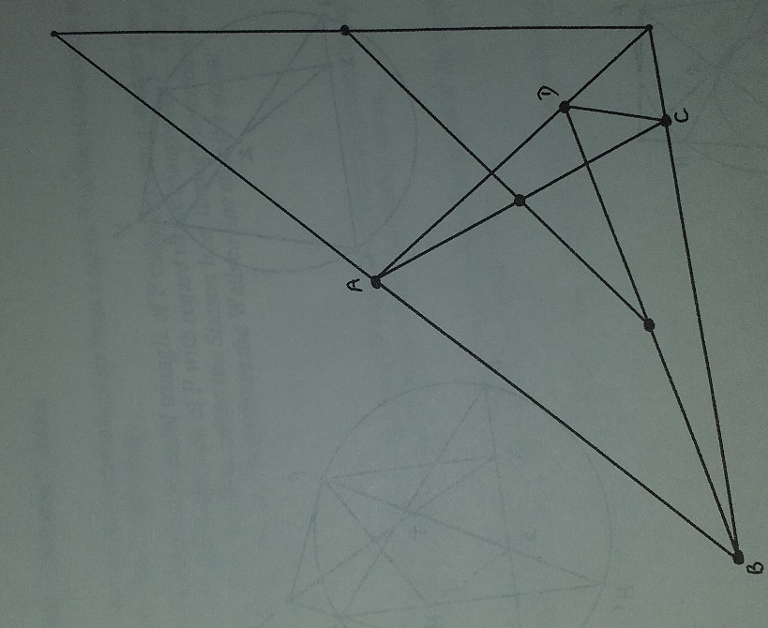

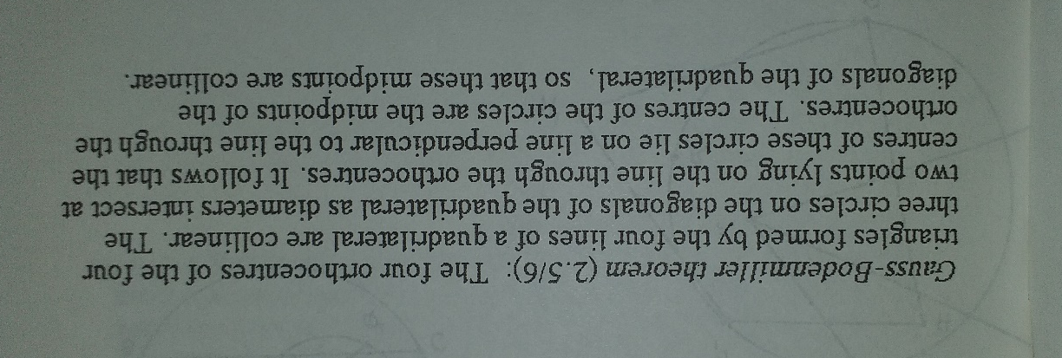

After this, if you want more, the first 6 parts of Dick’s original booklet are posted under ‘Dick’s triangle booklet’. The work in these sequences covers most of the first 4 parts but in a different order.

